Expression of Interest for Inclusion in the
Town & Village Renewal Scheme 2019

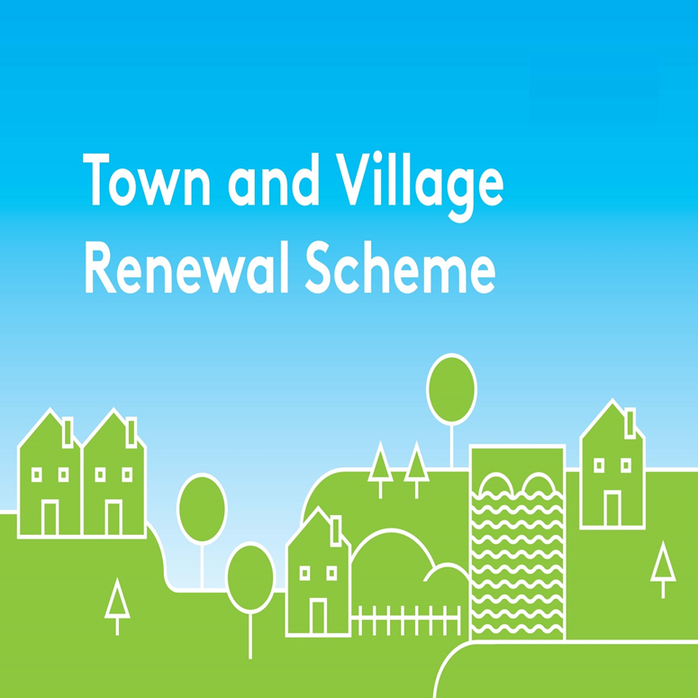
Please complete this Expression of Interest form and return it to
Laois County Council
Áras an Chontae,
JFL Ave.,
Portlaoise,
Co. Laois,
R32 EHP9.

Town & Village Renewal Scheme 2019

Town/Village covered:

Please indicate which category of funding is being applied for:

Category 1 Category 2

Towns/Villages with Towns/Villages with

Population of 5,000 Population of

or less 5,001-10,000

Amount of Funding Requested:

Applicant Group:

Applicant Contact Name:

Applicant Contact Address:

Applicant Telephone Number:

Applicant Mobile Number:

Applicant Email Address:

- Has funding for this project ever been sought from other sources? Yes No
(If "YES" yes please specify from what source and if funding was provided)

- Who are the specific project stakeholders/community partners in this project?
(Chamber of Commerce, Community group, etc.).

- Synopsis of Project:
- If seeking funding of between €100,000 and €200,000, please detail the particular economic case for this level of funding.

- What is the objective of the proposed project and how will the intended outcomes be measured? (Please identify any metrics or benchmarks that will be applied).

DECLARATION
I hereby confirm that I have read and understand this document. I request that consideration be given in support of the project as outlined above.

Signature __________________________________________________

Position __________________________________________________

Date __________________________________________________

Data Protection
In accordance with the General Data Protection Regulations 2018, the definition of personal data is - ‘personal data' means any information relating to an identified or identifiable natural person ('data subject'); an identifiable natural person is one who can be identified, directly or indirectly, in particular by reference to an identifier such as a name, an identification number, location data, an online identifier or to one or more factors specific to the physical, physiological, genetic, mental, economic, cultural or social identity of that natural person.
Laois County Council creates, collects and processes a significant amount of personal data in various multiple formats on a daily basis. Laois County Council’s commitment is that the personal data you may be required to supply to us is:
- Obtained lawfully, fairly and in a transparent manner
- Obtained for only the purposes of the Community Projects (Elected Members) Fund 2019.
- Adequate, relevant and limited to what is necessary for purpose for which it was obtained. Data will be used for administration purposes and financial purposes. Necessary information will be shared with the Accounts Payable Section of Laois County Council for the purposes of grant payments. Data may be used for audit purposes.
- Recorded, stored accurately and securely and where necessary kept up to date.
- Data will be kept securely in the Community Development Section of Laois County Council for a period of 6 years after completion of the project, after such time it will be destroyed.
- Legal basis – Local Government reform Act 2014

Your Data Protection Rights
You have the right to request access to personal data held about you, obtain confirmation as to whether data concerning you exists, be informed of the content and source of data and check its accuracy. In addition, if the data held by us is found to be inaccurate you have the right to change, remove, block, or object to the use of, personal data held by Laois County Council. In certain circumstances blocking access to data may delay or remove access to a service where the data is required by law or for essential purposes related to delivery of a service to you. Please note that to help protect your privacy; we take steps to verify your identity before granting access to personal data.
To exercise these rights you should take the following steps:
Forward your completed request to the Data Protection Officer at the following address:
Data Protection Officer,
Laois County Council,
County Hall,
Portlaoise,
Co. Laois.
R32EHP9
Or by email to: dataprotection@laoiscoco.ie

