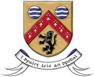

CALL OUT FOR ARTISTS FOR

LAOIS FESTIVAL OF FLIGHT

SUMMARY FORM

Additional information can be attached in one document (up to 10MB)

Artist’s name
Artistic Discipline
Name & Postal Address for contact person
Phone number(s)
Website if applicable
Email for contact person
Title of workshop
Description of workshop
(300 words max)
Amount applied for
Signature of Artist

