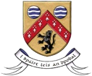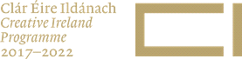

SHORT SUBMISSIONS FOR SELECTION

FOR LAOIS SCREEN NETWORKING EVENT

Submit to alawlor@creativelaois.ie by midnight on Tuesday October 11, 2022. Your submission will be acknowledged within a number of days of receipt. If you do not receive an acknowledgement within 3 days please follow up with an email to alawlor@creativelaois.ie and cc artsoff@laoiscoco.ie

Name of Film

Link to Screener

Link to Trailer (if available)

Director
Producer
Writer

Year of Production

Locations Used in Laois Used
Cast

Tagline

Synopsis

JPEG or PNG | A maximum of 4 publicity stills/posters including landscape and portrait to be attached with your submission – no more than 2MB
Hi-Res format | Files should be mac compatible  Screen resolution should be 1080p (HD)  Preferred codecs are PRORES 422 PROXY, PRORES 422 LT, PHOTOJPG, HAP

