,
Laois County Council,
Planning Department,
Aras an Chontae,
James Fintan Lalor Ave,
Kylekiproe
Portlaoise
Co Laois
R32 EHP9

Date of Application: 29/10/2021

RE: Licence Application under S. 254 of the Planning and Development Act, 2000 (the “Act”), for overground electronic communications infrastructure and associated physical infrastructure.

Further to our pre-application review held on the 25/08/2021, NBI Infrastructure DAC (“NBI”) applies for a licence under Section 254 of the Act for overground electronic communications infrastructure and associated physical infrastructure as described in Schedule One (the “Development”) at the location(s) described in Schedule Two (the “Works Parameters”).

NBI confirms that it has:

- consulted with the Local Authority in relation to the locations within the scope of this application;
- reviewed the Development and have concluded that the Development is “exempted development” within the meaning of the Act and the Planning and Development Regulations 2001;
- ensured that the proposed Development and associated works will not cause any issue that would endanger public safety by reason of traffic hazard or obstruction to road users;
- located poles in accordance with its design Guidelines for Assessing Locations for New Roadside Utility Poles;
- ensured the Development does not consist of works along, adjoining, in, on, under or over any land comprised in a motorway, busway or protected road; and
- created a T1 in the MRL system as set out in Appendix 1.2 of ‘Guidance on the Process of Engagement between NBI and Local Authorities on the Application for Section 254 Licences’.

Yours faithfully

Padraig Herlihy

___________________
NBI Infrastructure DAC

Schedule One: Description of the Works

The erection of overground electronic communications infrastructure and any associated physical infrastructure along public roads including:
- The erection of new overground fibre optic cables on existing timber poles
- The erection of new poles and associated fibre optic cables
Poles do not exceed 12 metres in height or approximately 0.3 metres in diameter and are manufactured to EN14229: 2010 and further described in Schedule Two.

Schedule Two: Works Information Parameters

Local Authority: | Laois County Council
Engineering Area/ Municipal District: | Borris-in-Ossory – Mountmellick MD
MRL T1 Application reference number: | 2021LS0403
Number of new poles: | 29
Overall length of associated cable | 94368m
Drawing of typical pole | 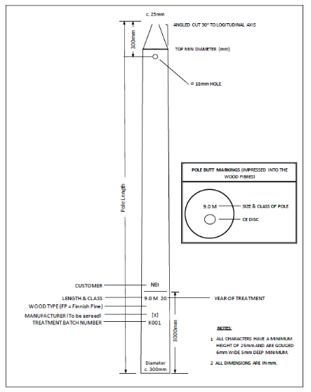
New Pole locations: | Described in the electronic PDF booklet⁸ provided via the MRL systems with a  cover sheet referencing the pole design information⁹. Pole location and design details are provided in the PDF booklet with one page per pole and with a  - unique reference number;  - photograph;  - location map; and  - design information  For ease of reference the locations may also be viewed at maps.arcgis.com (url link included in the T1 application detail on the MRL system)
Cable routes: | As described in the following drawings provided on the MRL system and relating to this application¹⁰.  [94368m]
‘Arc GIS Mapping Link’ | A link to an ArcGIS mapping file which shows the locations of all proposed poles. Each pole to be identifiable/ tagged with a pole reference number and have a popup to provide:  - the survey information fields defining the pole design inputs and outputs (including distance of proposed pole from edge of road)  - A Google Maps Streetview link to the pole location ; and  - 2 Photograph(s) of the pole location to define the proposed pole location using a surveyor ranging rods to denote proposed location (vertical rod) and distance from the road edge (horizontal rod).  The ArcGIS link includes background mapping of SAC areas to facilitate review.
Spreadsheet reference detailing pole design parameters submitted on MRL | Note:  The Excel document will list all new poles and the survey information which defines the pole design inputs and outputs i.e. estimated operating speed, road class, design offset etc.  The excel document is provided via the MRL system.
Screening Report Reference submitted on MRL. | Note:  A screening report may not be required in all circumstances. Where it is required, it will be provided via the MRL system.
Extract from AA Screening Report in relation to the specific works applied for in the application | Note:  A screening report may not be required in all circumstances. Where it is required, it will be provided via the MRL system.
NBI Internal Reference Number: | DA123-1-Johnstown- Borris-in-Ossory – Mountmellick MD
NBI Contact details in relation to this application. | Name: Padraig Herlihy  Telephone: 0873780051  e-mail: Padraig.herlihy@nbi.ie  Address: 3009 Lake Drive, Citywest, Dublin 24

⁸ A copy of which has been provided on the MRL system
⁹ PDF files at a layout scale that clearly shows pole location and surrounding locus at a suitable scale to determine the pole location relative to the public road and existing structures.
¹⁰ PDF files at a layout scale that clearly shows the extent of the NBI build in the deployment area with colour coded overground routes. Typically, 90% of the proposed build is achieved using existing poles and underground ducting, which do not require construction of new poles or underground ducting.

