**LAOIS COUNTY COUNCIL**

SHORT TERM LETTING OF PROPERTIES

Are you letting your property in full or part of?

Are you letting a house for short term periods?

Have you submitted the necessary forms to the Planning Authority?

Do you know someone who this may relate to….

REGULATION OF SHORT TERM LETTING

**Short term letting provisions apply in the designated Rent Pressure Zones of Portlaoise and Graiguecullen/Portarlington Local Electoral Areas.**

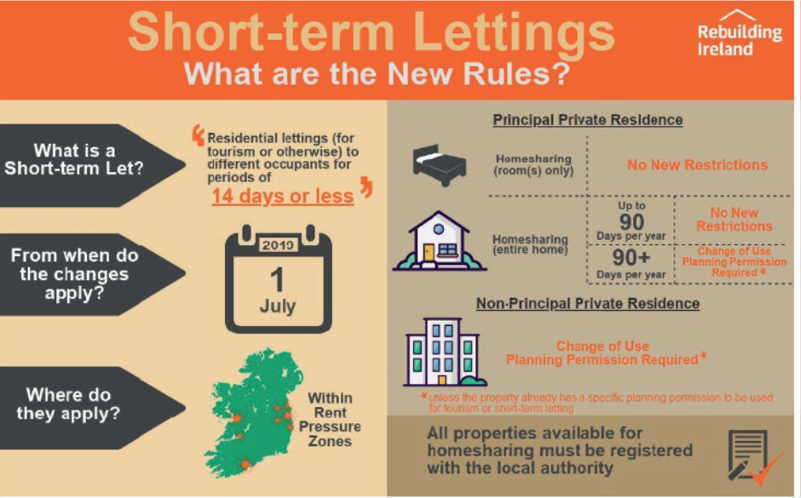

Short Term Letting Information and Forms are available on the Laois County Council website at the link below:

[**https://laois.ie/departments/planning/short-term-letting-2/**](https://laois.ie/departments/planning/short-term-letting-2/)

**Please contact** [**planning@laoiscoco.ie**](mailto:planning@laoiscoco.ie) **for further information and assistance**