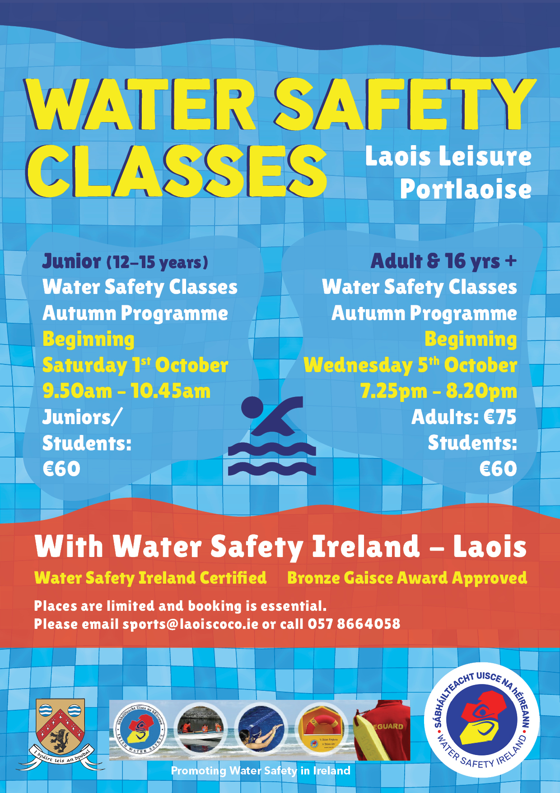

Registration Form for Autumn Programme 2022

Junior Classes 12-15 yrs (Saturday) Adults & 16 + (Wednesday)

Name 1: _____________________________________________________________
Date of Birth: _________________________________________________________
Medical History (If Any): ________________________________________________
Contact Phone Numbers: _______________________________________________
Address: _____________________________________________________________
_____________________________________________________________

Name 2: _____________________________________________________________
Date of Birth: _________________________________________________________
Medical History (If Any): ________________________________________________

Name 3: _____________________________________________________________
Date of Birth: _________________________________________________________
Medical History (If Any): ________________________________________________

In case of emergency, every effort will be made to contact the next of kin.
Failing to make contact I give my permission to the Wafer Safety Ireland – Laois Committee
to secure proper emergency treatment while efforts to locate the next of kin continues.

Signature: _______________________________________________________

Parent/Guardian Signature (if u-18): _________________________________

Photos may be taken at water safety classes for promotional use. If you have any issues with regards to this matter, please contact Water Safety Ireland - Laois
on (057) 86 64058 or email sports@laoiscoco.ie
For Official Use Only:
Amount Paid: ______________________ Receipt No.: __________________

