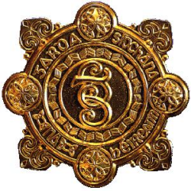
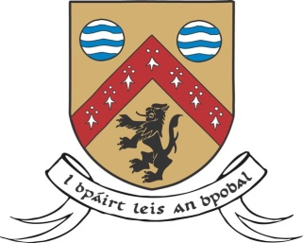
County Laois Joint Policing Committee – Annual Public Meeting
A public meeting of Laois County Joint Policing Committee will be held in the Dunamaise Arts Centre, Church Street, Portlaoise on:
Monday, 16th November 2020 at 3.30pm
The function of a Joint Policing Committee is to serve as a forum for consultations, discussions and recommendations on matters affecting the policing of the local authority administrative area. Members of the public have the right to make their views known and submit questions to the Joint Policing Committee. Questions will be accepted by the Joint Policing Committee from any individual member of the public, or collectively from any group/organisation.
Questions in relation to the above, or any other relevant topic, should be submitted in advance in writing to Ms. Elaine Moore, A/Administrative Officer, Community Development, Laois County Council, Áras an Chontae, Portlaoise, Co. Laois, by email to dce@laoiscoco.ie or by phone at Tel. (057) 8664107, no later than 4.30pm on Wednesday, 28th October 2020
It should be noted that in certain circumstances it may not be possible to provide the information requested. Name and contact details of those submitting the question should be supplied, but will not necessarily be publicised at the meeting.
Due to COVID 19 guidelines members of the public who wish to attend the meeting should also apply in advance to the Community Section, Laois County Council, as per contact details indicated above. Numbers are strictly limited in accordance with Government Guidelines.

