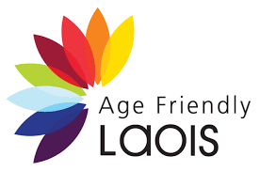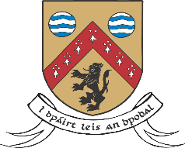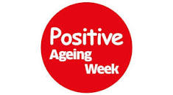
Age Friendly Laois launches “Reframing Aging” Campaign
Positive Ageing Week 2022 (PAW) runs from 25th September to the 1st October, 2022 and celebrates ageing and the contribution and agency of older people. The theme of PAW 2022 is Challenging Ageism -Reframing How We Think, Feel and Act about older age.
Laois County Council, through its Age Friendly Laois & Healthy Laois programmes are fortunate to have interactions with the older Laois Community and can see first hand their capabilities, qualities, knowledge and experience. As part of the launch of “ Reframing Aging “ campaign , we have profiled some of them here. Healthy Laois, in delivering its Live Well, Age Well programme , aims to support its citizens in maintaining a healthy and happy lifestyle, regardless of age or ability.
The national Age Friendly Ireland Programme (info on agefriendly.ie) supports cities, counties and towns across Ireland to prepare for the rapid ageing of our population by paying increased attention to the environmental, economic and social factors that influence the health and well-being of older adults.
Age-friendly programmes work to provide walkable streets, housing and transportation options, access to key services and opportunities for older people to participate in community activities. By doing so, these communities are better equipped to become great places, and where appropriate lifelong homes, for people of all ages.
Ageism refers to how we think (Stereotypes), feel (Prejudice) and act (Discrimination) towards others or ourselves based on age. It is harmful and has far-reaching impacts on all aspects of people’s health- physical, mental & social well being. It takes a heavy economic toll on individuals and society. The Global campaign to combat Ageism states that 1 in 2 people worldwide are ageist, and that this is particularly true in Europe. They state that ageism affects us throughout life and that it exists in our institutions and our relationships and that ageism exacerbates other disadvantages an older person may have.
Ageism can be combatted through policy and law , but mainly through education and awareness. We must recognise, acknowledge and appreciate past , present and future contribution of the older people in our community and minimise any generational disconnect that exists. Ageism is difficult to understand as it is an inevitability that we all get old and we should treat older people as we ourselves would like to be treated in our own later years.
For more information on this campaign, or indeed anything relating to the Age Friendly Laois programme, please contact Tom Curran on agefriendly@laoiscoco.ie or 05786 64150

Creativity doesn’t Age
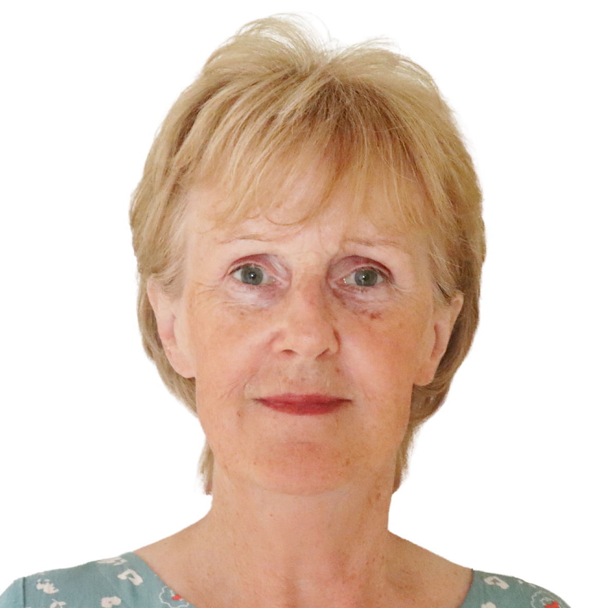
Trish Kelley tapped into her creative streak by joining Yarnbombing Mountmellick back in 2014. Trish hadn’t held a crochet hook since primary school. With a demanding career, she managed only to have enough time to be an ardent Liverpool supporter, and to do a little gardening.
Tapping into the right side of her brain has been a revelation. A nurse by profession, the health benefits of immersing oneself in crafting pursuits are irrefutable for Trish. Creativity is great for your health! Being a member of a group whose tagline is “a herd of a different colour” is a prescription for wellbeing, improved brain neuroplasticity and cognitive function. Whether pondering colour combinations, puzzling over crochet patterns or pouring over YouTube tutorials, age is no barrier to innovation or imagination. Creativity has informed all areas of her life now. Attending Electric Picnic last weekend, she felt right at home amongst the colour, finding inspiration all around her. Trish quotes the author Ursula Le Guin “The creative adult is the child who survived.” A great message for us all!

Resilience doesn’t Age
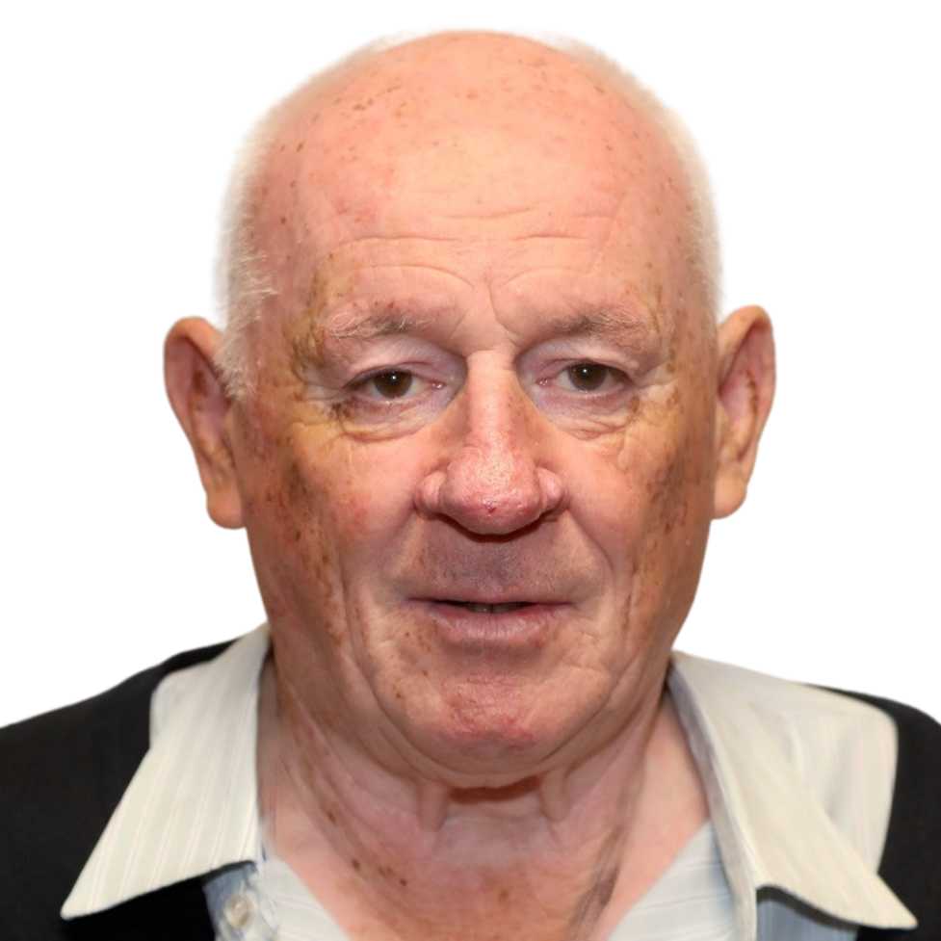
Jim Fennelly is from Abbeyleix and worked with the ESB for 33 years until a workplace accident in 2007 meant that Jim has had to use a wheelchair since. This has not stopped Jim, however, and since his accident , he has devoted a lot of his life to a passion of his since the age of 12- photography. Jim’s images can be seen on JimKathleen Fennelly facebook page- his latest photos being from the Electric Picnic on his “ All Terrain Motorised Wheelchair”, which he says “can go anywhere”. Being in a wheelchair hasn’t stopped Jim , and he remains as actively engaged with his community as ever, forming a camera club in his hometown of Abbeyleix , among other achievements. Jim can also be seen regularly at the Field equestrian centre, another love of his. Jim is a good conversationist and time flies by in his company.
He is a great example of how barriers got be got around or even knocked down!!!!!

Courage doesn’t Age
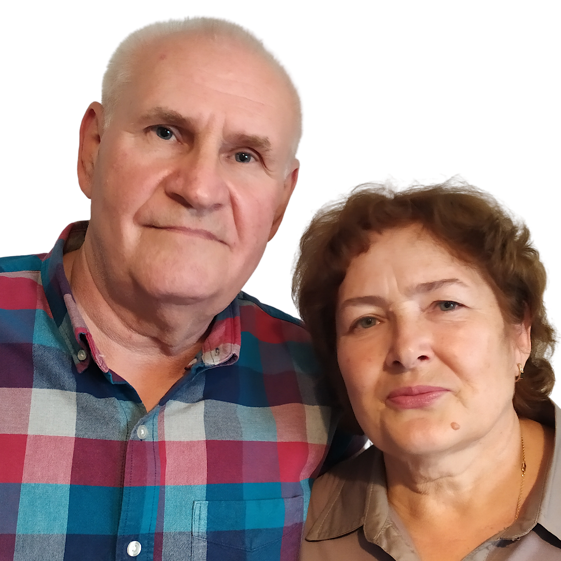

Viktor & Liudmyla Shokhin came to Ireland in April 2022, after the outbreak of war in Ukraine, following their daughter & grandchildren who had come to Ireland in March. Vickor is a retired engineer and Liudmyla a retired teacher, who still hears from her former pupils in Ukraine. They made the decision to come to Ireland due to the war and to support their daughter and family. Viktor loved to fish in the rivers of Kyiv with his grandchildren and has brought them fishing in Ireland to continue that with them. It has been a huge change in their lives but they are adapting, with Liudmyla taking English classes to further help them to settle and support their family.

