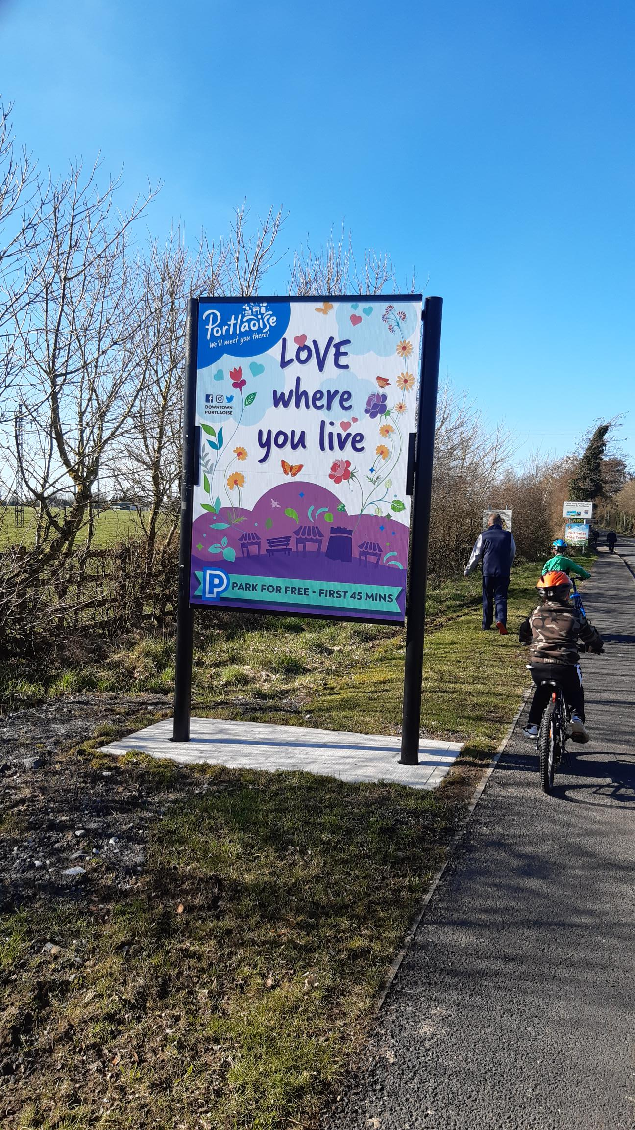

**PUBLIC INFORMATION SESSIONS**will be held at Laois County Council Offices, Aras an Chontae, Portlaoise on:

**Thursday 18th April 2024: 11am - 1pm and 2pm - 5pm**

**Thursday 25th April 2024: 11am - 1pm and 2pm - 5pm**

The Draft LAP and associated documents will be on display from **5th April 2024 to 17th May 2024**and available to view at:

* **Online:** [**http://consult.laois.ie**](http://consult.laois.ie/)
* **Laois County Council,**Áras an Chontae, JFL Ave., Portlaoise
* **Portlaoise Library,**Main Street, Portlaoise

**PUBLIC CONSULTATION**

**The Local Area Plan process provides you with an opportunity to help shape the future development of Portlaoise**

**LAOIS COUNTY COUNCIL**

**DRAFT PORTLAOISE**

**LOCAL AREA PLAN**

**2024 – 2030**

