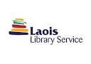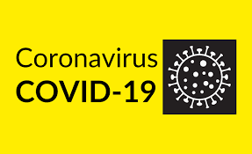

Volunteer Laois and Laois County Council Library Services delivering books to cocooning persons

Are you cocooning with no access to books or reading material or do you know someone who is elderly or vulnerable and who is cocooning at home? You can request a selection of library books, audio-books and DVDs directly from Laois County Council Library Services
To avail of this service you can contact the following library branches
Portlaoise: 057 8622333 Tuesday- Saturday 10.00am-1.00pm and 2pm-5pm
Mountmellick: 057 8644572 Tuesday –Friday 10.00am-1pm and 2-5pm
Or you can email: laoislibrary@laoiscoco.ie
Mountmellicklibrary@laoiscoco.ie
How does it work?
Patrons cocooning can contact Mountmellick and Portlaoise branch libraries
Library staff will take details and select suitable library material
If the particular book you are looking for is not available you can ask staff for books on other authors in same genre or ask library staff to make a selection for you.
Volunteer Laois volunteers will then make arrangements with you to deliver these library items to your doorstep.
All items are on long loan, there are no overdue fines or fees and access to the service is always FREE.
https://laois.ie/departments/libraries/find-a-book/
https://laois.ie/departments/libraries/joining-the-library/get-a-library-card/
