Callout for Artists’ Studios, Laois Arthouse, Stradbally, Co Laois.
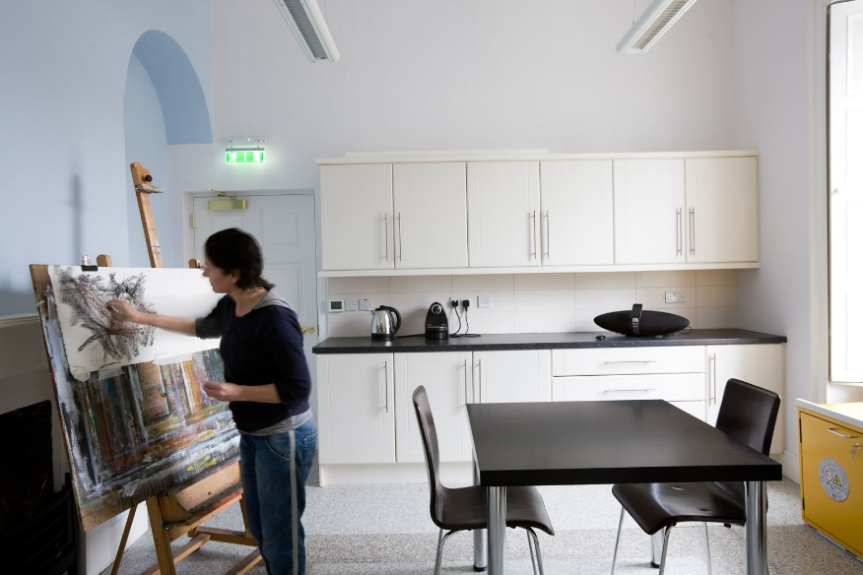
The Laois Arthouse is seeking applications from professional artists working in any artform for subsidised studios from March 2024.
The studios are private working spaces. They can be accessed seven days a week. Each studio is equipped with a desk, chair, electrical points, natural and artificial light, sink and storage. Wifi and electricity is covered in the studio agreement.
The studios are available for 3 months minimum to one year, which can be extended at the discretion of the County Council. The studio fee is €250 per month, payable in advance along with a €200 deposit

The Laois Arthouse contains a gallery, a kiln, five studios and two residential apartments. Workshops, tours and classes for children, adults and professional artists are hosted at the Laois Arthouse as well as events throughout the year. The public library is located to the front of the building in which the Laois Arthouse is situated.
There are facilities attractive to artists located nearby, including Mc Keon Stone, the foremost limestone yard in Ireland, which has a history of supporting sculptors, the Malthouse, a privately owned facility where several annual cultural events are held and the Cosby estate, where the renowned Electric Picnic music and arts festival is held annually.

- Applications should be emailed to artsoff@laoiscoco.ie with the subject heading ‘Laois Arthouse’ including:
- A cover letter outlining whin you would like a studio at the Laois Arthouse
- Artists‘s biography
- Documentation of previous work
- Closing date for the receipt of completed applications is Thursday 22th February 2024 at 5.00pm.
Information Session: Laois County Council Arts Service will host two information sessions on upcoming grants, studios and funding opportunities in 2024.
In-person: Thursday 18th January 2024 at 7:00pm at Dunamaise Arts Centre, Portlaoise.
Online: Tuesday 23rd January 2024 at 7:00pm via Microsoft Teams.
Please email artsoff@laoiscoco.ie to register.

