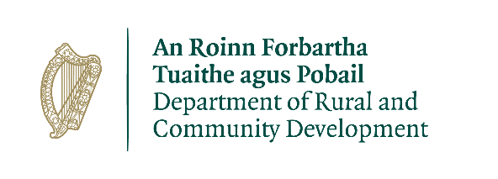

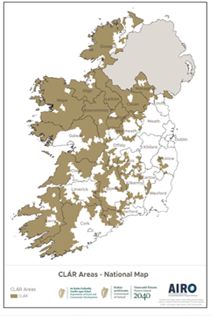

**CLÁR Funding 2021**

**INNOVATION MEASURE OUTLINE**

**Background**

The CLÁR Innovation Measure is targeted at piloting new ideas which address specific challenges faced by communities in CLÁR areas, including those associated with rural isolation, village decline, service accessibility, population change, social disadvantage and marginalisation in communities within the CLÁR areas. This Measure seeks to support fresh ideas and new ways of working that might not otherwise be identified or supported.

**Possible Projects**

The Measure is looking to assist projects that:

* demonstrate new ways of working that help deliver outcomes for the area/community; and/or
* encourage cross-organisational or cross-community working; and/or
* considers the use of new and emerging technologies, tools or methodologies in relation to the delivery of services; and/or
* implement approaches and ideas that can be spread elsewhere.

**Application Process**

It is proposed to invite Expressions of Interest (EOIs) directly to the Department from Local Authorities, Local Development Companies, community groups and representative bodies for businesses and other organisations located in CLÁR areas.

The EOIs will be reviewed and evaluated in the context of the objectives of the Fund and the overall available funding available. Additional information to complete the assessment process may be requested from the EOIs, particularly those identified as offering the best potential for delivering successful outcomes in line with the Department’s objectives. Successful projects may be approved and announced in different tranches under this scheme during the course of the year, as and when they are evaluated and deemed appropriate for funding.

The applicant must ensure that the expression of interest form is fully completed and complies with the 2021 CLÁR Innovation Measure outline.

**Eligible Applicants**

This measure will be operated directly by the Department of Rural and Community Development and is open to Local Authorities, Local Development Companies, community groups and representative bodies for businesses and other organisations.

Support will be made available to applicant groups/organisations that are **formally established** e.g. company limited by guarantee etc. Support will **not** be made available to individuals or ad hoc groups. It will be necessary to provide information/certification regarding the formal establishment of the group/organisation e.g. Memoranda and Articles of Association.

**Rate of Aid**

* The minimum level of funding available per proposal is €5,000 up to an indicative maximum of €50,000. To aid and reflect the disruptive innovative nature of this Measure, the level of match funding may vary based on the nature of the project. Community groups, in particular, will be eligible to apply for up to 95% funding. The level of matching funding should be proposed by the applicant as part of the EOI process and will be assessed by the Department in the context of the type of actions proposed in the EOI.
* Philanthropic contributions will be accepted as full or part of match funding costs.

As this grant involves the spending of public funds, it is essential that good value for money is derived from it. **Successful applicants** are therefore required to comply with relevant public procurement guidelines.

Guidance on this is available from the Office of Government Procurement (website: www.OGP.gov.ie; email: [support@OGP.gov.ie](mailto:support@OGP.gov.ie) phone: 076 100 8000).

**Assessment Criteria**

The following is the assessment criteria –

|  |
| --- |
| **Relevant Experience & Governance/Management Structure**   * The relevant experience, track record and achievements of the applicant in developing collaborative initiatives with local stakeholders * Adequacy of governance arrangements to manage funding and financial viability of the organisation |
| **Fit with Programme Objectives**   * How well the project would meet the objectives of the pilot * How sustainable the impact of the proposed project would be on completion of the pilot |
| **Strength of Proposal**   * Quality of proposal and approach showing * Evidence of need * How the proposed initiative will improve services * Clear attainable and measureable targets * Anticipated outcomes for participants * The quality of project outcomes |
| **Value for Money**   * Quality of the outcomes for the proposed budget * Clear and well-structured budget * Costs are in line with market norms |

**Timelines**

Expressions of Interest should be submitted directly to the Department at [CLAR@DRCD.gov.ie](mailto:CLAR@DRCD.gov.ie) by the Friday 21st May 2021.

The Department may not be in a position to follow up regarding missing documentation or incomplete forms. Incomplete forms may not be considered.

**Queries**

Any queries should be submitted to [**CLAR@DRCD.gov.ie**](mailto:CLAR@DRCD.gov.ie)**.**