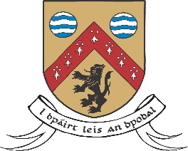

Laois County Council
Creative Ireland Community Project Application Form 2024
Please submit the following in full, having read the Grant Information– note all questions need to be answered in order for a full assessment of your application

Community Group and contact person
Artist’s name
Artistic Discipline
Postal Address
Phone number(s)
Website if applicable
Email for contact person
Aspect of Heritage to be Explored
(no 1 on Grant information sheet)
Title of Proposed Project
Details of the Proposal
(see no 6 on Grant information sheet)
Is the project exploratory or project delivery in 2024
Timeframe
Key delivery dates to be listed (see No 4 on grant information sheet)
Was your community group successful with a 2023 Heritage through Art application, if so has the project been completed.
Budget Sought
(see no3 on Grant information sheet)
Include full list of expenses here
Bank Account/ sort code/
IBAN number
Tax Clearance Number
Weblinks to relevant work by artist or community

Please address your application to Creative Ireland Open Call Community Project
Email: creativelaois@laoiscoco.ie and cc dabroderick@laoiscoco.ie (max size per email 10MB) by 12.00pm on Monday April 1st 2024.

