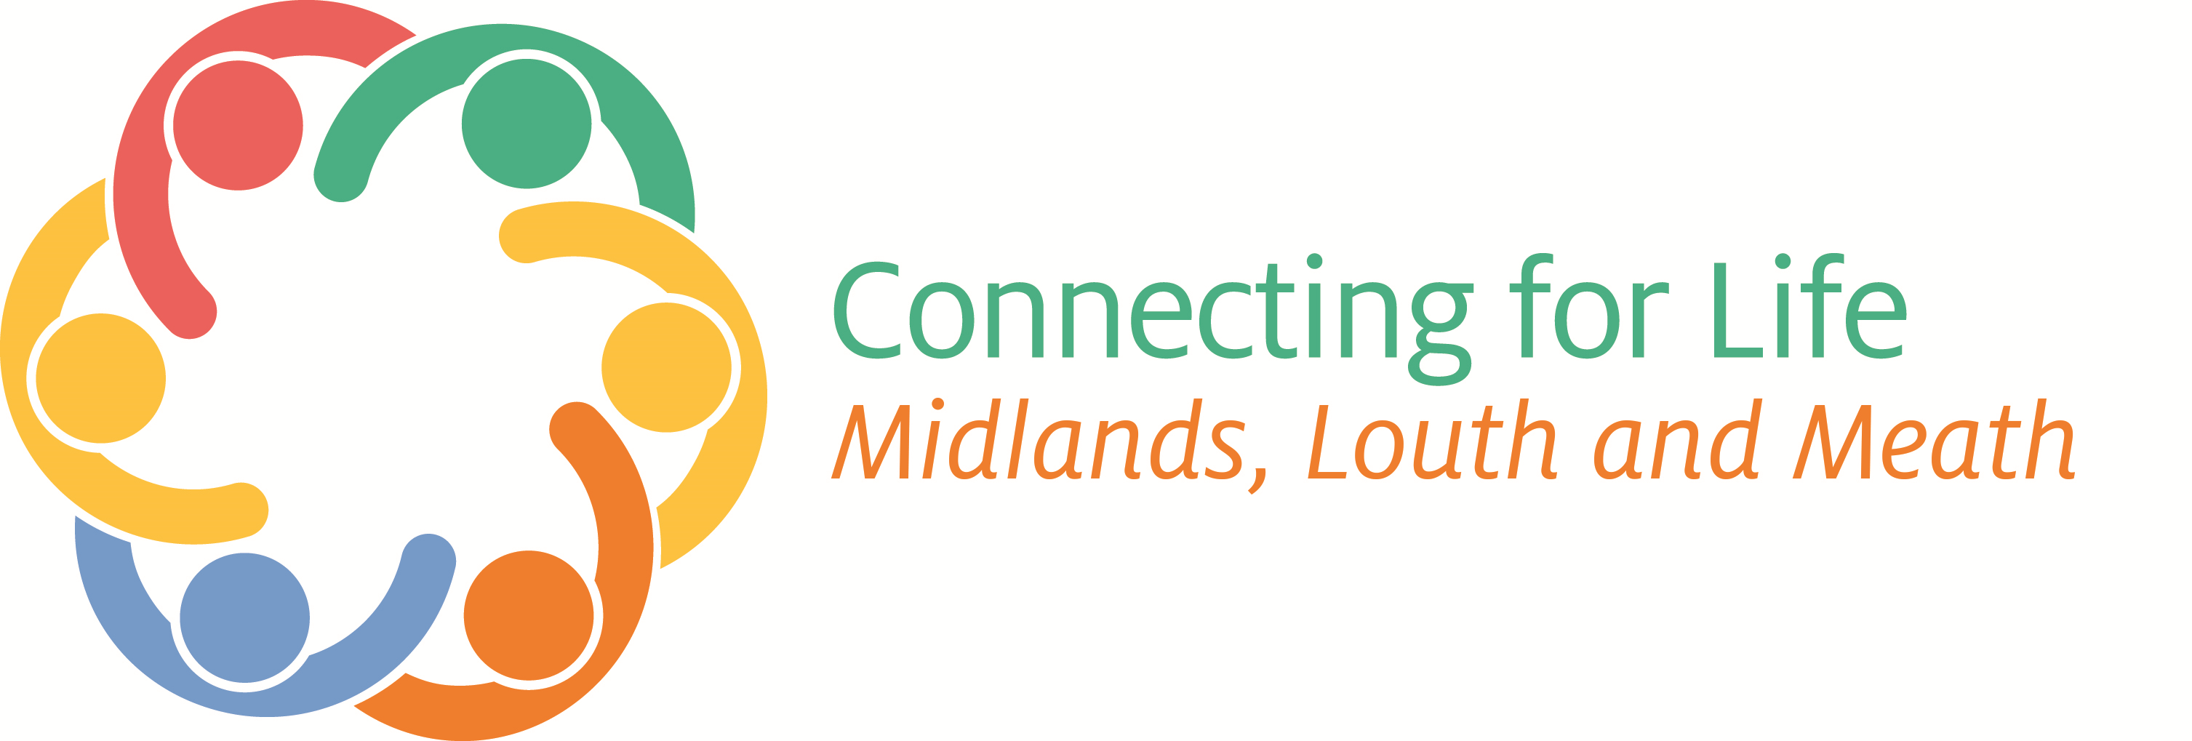
HSE MIDLANDS (Laois/Offaly and Longford/Westmeath)
Face to face Suicide Behaviour Awareness & Training Programmes
July - October 2022
(subject to additions – check booking site: https://bookwhen.com/suicidepreventiontrainingmidlands


SafeTALK is a 3hr ‘suicide alertness’ programme that prepares participants to identify and engage with persons who may be having thoughts of suicide by using the steps of TALK (Tell, Ask, Listen and Keepsafe) Individual safeTALK Workshops can be delivered upon request to groups with a min of 12 participants by contacting your Resource Officer (contact below). Booking via: https://bookwhen.com/suicidepreventiontrainingmidlands
Laois/Offaly: |  | Longford/Westmeath:
Date and Time: | Venue: | Date and Time: | Venue:
27th July: 9.30am – 1pm  8th Sept: 9.30am – 1pm  15th Sept.: 9.30am – 1pm | Portlaoise, Co. Laois.  Tullamore, Co. Offaly. Portlaoise, Co. Laois. | 19th July: 9.30am – 1pm  22nd Sept: 9.30am – 1pm. | Mullingar, Co. Westmeath  Mullingar, Co. Westmeath

Understanding Self-Harm (USH) 
This 1 day awareness training programme covers issues relating to self-harm including definitions, prevalence
rates, myths, causes, motivations and functions of self-harm, supportive responses, treatments and services.
DVD clips containing contributions from service providers and individuals with lived life experience of self-harm supplement the programme. Booking via: https://bookwhen.com/suicidepreventiontrainingmidlands
Laois/Offaly: |  | Longford/Westmeath:
Date and Time: | Venue: | Date and Time: | Venue:
29th September:  9.30am – 4pm | Laois Education Cntr., Portlaoise, Laois. | To be arranged.


A.S.I.S.T. (Applied Suicide Intervention Skills Training) is a 2-day skills based, intensive, interactive and practice-dominated Workshop designed to help Caregivers recognise the immediate risk of suicide and learn how to respond and be in a position to provide immediate safety, help and information to individuals whose lives may be at risk. Booking via: https://bookwhen.com/suicidepreventiontrainingmidlands
Laois/Offaly: |  | Longford/Westmeath:
Date and Time: | Venue: | Date and Time: | Venue:
11th and 12th October:  9am – 5pm both days. | Tullamore Court Hotel,  Tullamore, Co. Offaly. | 25th and 26th October:  9am – 5pm both days. | Bloomfield House Hotel,  Mullingar, Westmeath.

SELF-DIRECTED ONLINE PROGRAMME:
LivingWorks Start is for those who want to help prevent suicide and develop the skills to assist someone who may be at risk of suicide. It can be completed in 1½ hours and includes a four-step model and impactful simulations. (Over 18yrs) Booking via: https://bookwhen.com/suicidepreventiontrainingmidlands

To register on any of the above programmes, log onto https://bookwhen.com/suicidepreventiontrainingmidlands or Queries: Josephine Rigney, HSE Resource Officer for Suicide Prevention Midlands
Email: josephine.rigney@hse.ie or Mobile: (086) 815 7850.

