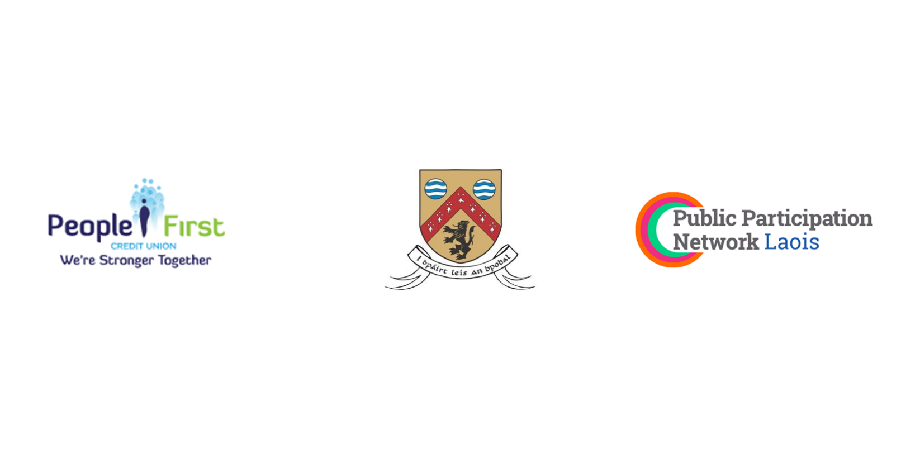

**Laois County Council**

***In partnership with***

***Laois Public Participation Network***

***and our long-term Corporate Sponsor***

***People First Credit Union***

**Community & Voluntary Awards 2024**

**Nomination Form**

***Unsung Hero***



***This form should be used to nominate an individual in recognition of***

***their significant contribution to Community & Voluntary life in County Laois***

***Only one nomination per person.***

**N.B. Before completing this form, please read the accompanying terms & conditions and judging criteria**

**TERMS & CONDITIONS:**

1. To ensure judging is fair and impartial, judges will be selected from outside of County Laois.
2. Please ensure the person being nominated is aware of and has consented to the nomination.
3. Previous Unsung Hero award winners can not be nominated in any subsequent year.
4. It is very important that as much information as possible is given on this Nomination Form. This will ensure Judges have a good understanding of the work of the Nominee.
5. Please submit a minimum of **two good quality digital photographs** to accompany the application form. Photographs should be of good quality and may be used for publication.
6. Photographs may be used by Laois County Council in advertisements and publications about the Awards Ceremony, in posts on Social Media sites, be used in the Ceremony production and may be included in Council publications, to include but not limited to the Annual Report, Council Newsletter and Management Reports.
7. Nominees for Unsung Hero will receive an allocation of two tickets only for the Awards Night, with the nominator receiving one ticket only.
8. Nomination forms which don’t have all the required consents from all individuals/groups involved will be deemed invalid.

**CONSENT AGREEMENT:**

Please tick **ALL** to consent:

I confirm that I have the **Consent** of the **Nominated Individual** to furnish this application and to share their personal data with Laois County Council for this purpose.

I hereby consent I am sharing copies of photos and/or accompanying documentation, as part of the nominated application by email or post as originals may not be returned.

I confirm that I have the **Consent** of the **Nominated Individual** to be contacted by Laois County Councils staff members and other parties involved in the Community and Voluntary Award 2024.

I confirm that I have the **Consent** of the **Nominated Individual** for the use of photographs by Laois County Council in advertisements and publications about the Community and Voluntary Awards Ceremony, to be posted on Social Media sites, to be used in the Ceremony production and to be included in Council publications, to include but not limited to the Annual Report, the Council Newsletter and Management Reports.

**THE JUDGING CRITERIA**

|  |  |
| --- | --- |
| 1. Contribution to community and voluntary activities in their local area. | 1. Level of nominee participation in community group/s , support for projects and voluntary endeavours |
| 1. Impact of their community and voluntary activities on the local community. | 1. Positive impact on the local community / local area. |
| 1. Impact of their community and voluntary activities on the wider community. | 1. Positive impact on the wider community, at county, regional or national level. |

**Completed applications should be marked**

**“Unsung Hero Award 2024 Nomination”**

**and returned by email to** [**awards@laoiscoco.ie**](mailto:awards@laoiscoco.ie)

**or posted to**

**“Unsung Hero Award 2024 Nomination”**

**Community & Voluntary Awards 2024,**

**Community Section,   
Laois County Council,**

**Áras an Chontae, Portlaoise,  
Co Laois.**

**Closing Date is by 4 pm, 26th of July 2024**

**For further assistance and queries, please contact: (057) 8664236**

**or e-mail:** [**awards@laoiscoco.ie**](mailto:awards@laoiscoco.ie)

**Nomination Form**

**I wish to nominate the following person for an *Unsung Hero* Award:**

|  |  |
| --- | --- |
| **Name of the person being nominated** |  |
| **Address** |  |
| **Phone No. (daytime contact)**  **Mobile number** | C:\Documents and Settings\gireland\Local Settings\Temporary Internet Files\Content.IE5\YHXURAT4\MC900340830[1].wmf |
| **Email address for contact** | C:\Documents and Settings\gireland\Local Settings\Temporary Internet Files\Content.IE5\6F7AXZN2\MC900442124[1].png |

***Details of person or Group making the nomination:***

|  |  |
| --- | --- |
| **Your Name (individual/group)** |  |
| **Your Address** |  |
| **Phone No. (daytime contact)**  **Mobile Number** | C:\Documents and Settings\gireland\Local Settings\Temporary Internet Files\Content.IE5\YHXURAT4\MC900340830[1].wmf |
| **Email address for contact** | C:\Documents and Settings\gireland\Local Settings\Temporary Internet Files\Content.IE5\6F7AXZN2\MC900442124[1].png |

***Is the person you have nominated, a Member of a Community/Voluntary group/Organisation in Laois?***

**Yes** **No** **Don’t know**

**If yes, please name the group/organisation**

***Please highlight your Nominee’s current/recent contribution to their local community:***

***Please outline the reasons why you/your group wish to nominate this person for an Unsung Hero Award:***

***How do you think your Nominee has made a positive contribution to the community and voluntary activities in their local area and to the wider community ?***   
\****You can use a separate sheet to set this out if necessary***

* By completing and submitting this form, I hereby confirm that I have read and understand the terms and conditions and data protection requirements.
* In addition to the aforementioned, I hereby confirm that I have the Consent of the Nominee, in order to share their personal data, relevant for the administration of Laois Community and Voluntary Awards, 2024.

**SIGNED: DATE:**

***Nominator (Signature)***

**Community and Voluntary awards privacy statement / data protection statement can be found by clicking the below links.**

[**Community and Voluntary Awards privacy statement**](https://laois.ie/wp-content/uploads/CV-Privacy-Notice.docx)