**Laois County Council**

**September 2023**

Laois County Council development contribution scheme

2023-2029



**Table of Contents**

1. Introduction 4

2. Duration of Scheme 4

3. Legislation 4

4. Rationale 5

5. Types of Development Contribution Schemes 7

5.1. General Development Contribution Scheme 7

5.2. Special Development Contribution Scheme 7

5.3. Supplementary Development Contribution Scheme 7

6. Classes of Public Infrastructure and Facilities 7

7. Payment of Contributions 8

8. Appeals to An Bord Pleanala 9

9. General Provisions of the Scheme 9

9.1 Area of Calculation 9

9.2 Mixed Development 9

9.3. Ring Fencing of Income 9

9.4. Certificate of Compliance 10

9.5. Public Information 10

9.6. Temporary Permission 10

9.7. Retention Permission 10

9.8. Infrastructure in lieu 10

9.9. Double-Charging/ Demolition 10

9.10. Revisions/Modification to a permitted development 11

9.11. Car parking in cases of change of use development 11

9.12 Mixed use complementary parking 11

9.13 Outline Planning Permission 11

10. Methodology for Determination of Development Contribution Scheme 2023-2029 11

10.1 Overall Economic Climate 11

10.2. Local Context 12

11. Estimating the Nature and Scope of Future Development in County Laois 13

11.1. Residential 13

11.2. Non-Residential 13

12. Exemptions 13

12.1. Voluntary 14

12.2. Housing 14

12.3. Local Authority Own Development 14

12.4. Education 14

12.5. Community Enterprise Centres 14

12.6. Derelict Sites 14

12.7. Protected Structures 15

12.8. Renewable Energy 15

12.9. Telecommunications 15

12.10. Change of use permissions 15

13. Reductions 15

13.1. Employment Creation 15

13.2 Town Centre Rejuvenation 16

13.3 Clarification 16

13.4 Caveat 16

14. Temporary Time Limit Waiver 2023 16

Under Circular PL04/2023 the Government introduced a temporary development contribution waiver arrangement which will apply for 1 year to all permitted residential development – 16

15. Key Aspects of Development Contribution Scheme 2023-2029 17

15.1. Increase in Charges 17

15.2. Introduction of New Charges 17

15.3 Miscellaneous Development Categories 17

16. Implementation of Scheme 17

17. Development Contribution Scheme 2023-2029 Table 19

Appendix A: Range of Capital & Other Projects to be funded from the Scheme 21

# 1. Introduction

This Development Contribution Scheme applies to the administrative area of Laois County Council for the period 2023-2029 inclusive and has been prepared in accordance with the advice and guidance of the Dept of Environment 2013 benchmark document “*Development Contributions, Guidelines for Planning Authorities*”. It will replace the current 2017-2023 Scheme.

Subsequent to the date of its adoption, all planning permissions granted by Laois Council shall

be subject to this Development Contribution Scheme and development charges shall be levied

as appropriate as a condition of any permission issued under Section 34 of the Planning and

Development Act 2000 as amended.

In addition, the provisions of Section 29 of the Urban Regeneration and Housing Act 2015 shall apply.

# 2. Duration of Scheme

This scheme is effective for a period of six [6] years from date of adoption or until such time as a subsequent scheme is adopted.

Nonetheless, the Scheme may be reviewed from time to time by Laois County Council, having regard to the circumstances prevailing at any particular time.

# 3. Legislation

Section 48 of the Planning and Development Act 2000 as amended [hereinafter referred to as the Act] enables a Planning Authority, when granting planning permission under Section 34 of the Act, to include conditions requiring the payment of a financial contribution in respect of public infrastructure and facilities benefiting development in the area of the Planning Authority and that is provided, or that it is intended will be provided, by or on behalf of the Local Authority, regardless of other sources of funding for the infrastructure and facilities.

Under subsections [2] and (3) of Section 48, a scheme:

• *shall* state the basis for the determination of a contribution to be paid in respect of public infrastructure and facilities;

• *shall* indicate the contribution to be paid in respect of the different classes of public infrastructure and facilities which are provided, or to be provided by the Local Authority having regard to the actual estimated cost of providing the classes of public infrastructure and facilities, except that any benefit which accrues in respect of existing development may not be included in any such determination;

• *may* make provision for payment of different contributions in respect of different classes or descriptions of development;

• *may* require the payment of a Special Contribution in respect of a particular development where specific exceptional costs not covered by a scheme are incurred by a local authority in respect of public infrastructure and facilities which benefit the proposed development.

• *may* allow for the payment of a reduced contribution or no contribution in certain circumstances, in accordance with the provisions of the scheme.

The making of a Development Contribution Scheme is a reserved function of the Elected

Members of Laois County Council.

# 4. Rationale

A Development Contribution Scheme is a vitally important mechanism for the local authority.

Its primary objective is to ensure that developments benefiting from infrastructural investment pay a contribution towards the provision of infrastructure that is essential to enabling that development in the first place. This will promote sustainable development patterns and encourage wider economic activity, investment and job creation.

Development contributions provide the only statutory mechanism for capturing planning gain as part of the development management process.

In addition to funding from the central exchequer, development contributions have enabled much essential public infrastructure to be funded across County Laois since their inception in

2000.

From 2018 through 2021, **€6.3 million** of development contributions has been paid to the Council a significant sum bearing in mind the lengthy economic lockdowns associated with the Covid pandemic.

Development Contributions have supported the delivery of essential public infrastructure in Laois.

Examples include:

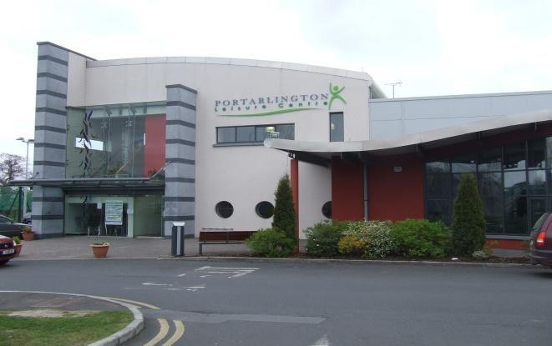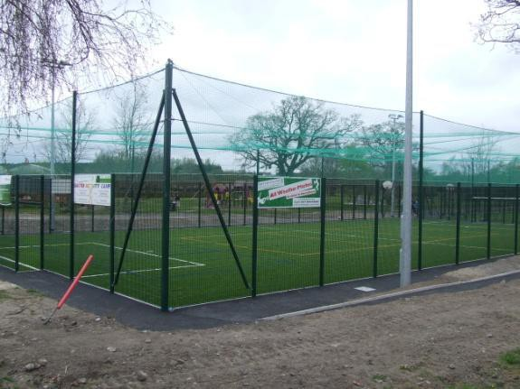

*Portarlington: leisure centre [left] and astro-turf pitch [right]*

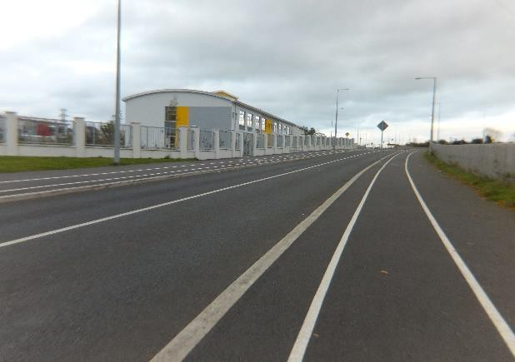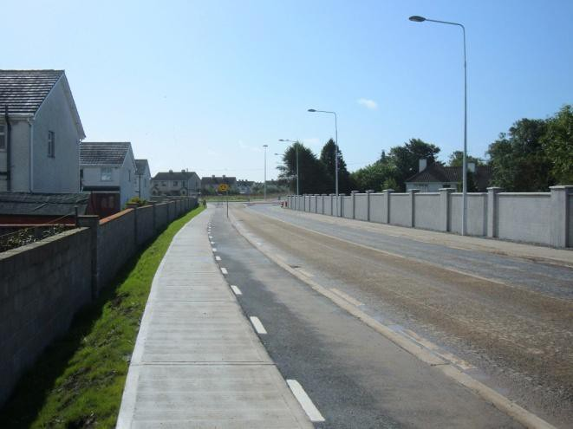

*Portlaoise: section of Southern Relief Route with new schools campus, [left] section of WOR at Clonrooske [right]*

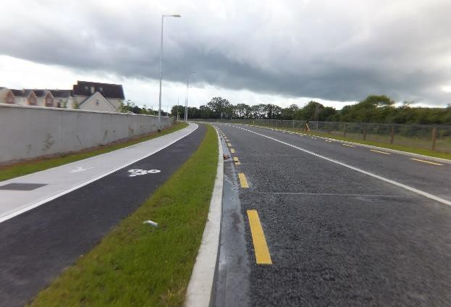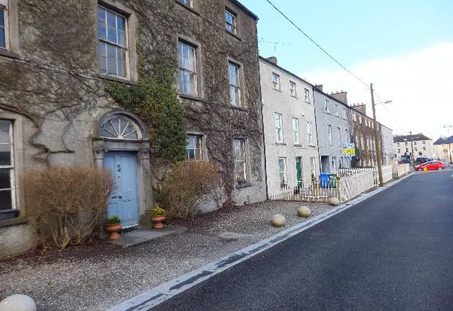

*Crossneen, Carlow: extended section of Northern Relief Road [left] and Durrow Square refurbishment [right]*

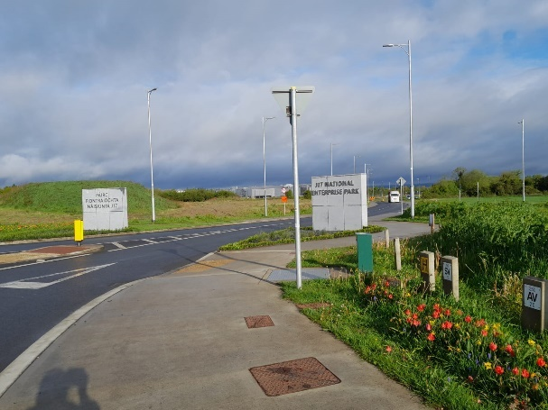 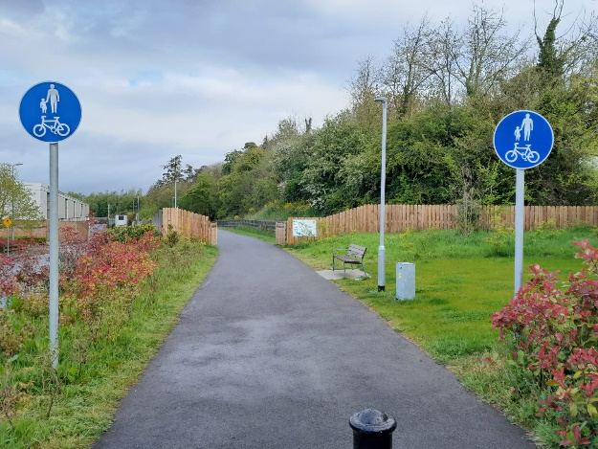

*Junction 17 National Enterprise Park Portlaoise Pairce Ui Pobail Portlaoise*

# 5. Types of Development Contribution Schemes

There are three types of Development Contribution Scheme, namely:

## 5.1 General Development Contribution Scheme

Under Section 48 of the Act, planning authorities must draw up a development contribution scheme in respect of certain public infrastructure and facilities provided by, or on behalf of, the local authority that generally benefit development in the area. All planning permissions granted are subject to the conditions of the development contribution scheme in operation in the area of the planning authority.

## 5.2 Special Development Contribution Scheme

A special development contribution may be imposed under Section 48(2)(c) where specific exceptional costs, which are not covered by the general contribution scheme, are incurred by a local authority in the provision of public infrastructure or facilities which benefit very specific requirements for the proposed development, such as a new road junction or the relocation of piped services.

## 5.3 Supplementary Development Contribution Scheme

Section 49 of the Act provides for the drawing up of a supplementary development contribution scheme to facilitate a particular public infrastructure service or project which is provided by a local authority or a private developer on behalf of and pursuant to an agreement with a local authority (for example through Public Private Partnership), and which will directly benefit the development on which the development contribution is imposed.

A good example of such schemes include those prepared to support the delivery of public transport projects like the LUAS network in Greater Dublin.

# 6. Classes of Public Infrastructure and Facilities

Section 48 [17] of the Act gives the following meaning to "public infrastructure and facilities":

• the acquisition of land;

• the provision of open spaces, recreational and community facilities and amenities and landscaping works;

• the provision of roads, car parks, car parking places, sewers, waste water and water treatment facilities, service connections, watermains* and flood relief work;

• the provision of bus corridors and lanes, bus interchange facilities (including car parks for these facilities) infrastructure to facilitate public transport, cycle and pedestrian facilities, and traffic calming measures;

• the refurbishment, upgrading, enlargement or replacement of roads, car parks, car parking places, sewers, waste water and water treatment facilities, service connections or watermains*;

• the provision of high-capacity telecommunications infrastructure, such as broadband;

• the provision of school sites and

• any matters ancillary to the above.

To simplify matters, the above development types have been categorized as follows:

• *[a] Transport and Drainage Infrastructure* including the provision, refurbishment, upgrading, enlargement or replacement of roads, car parks, car parking places, bus corridors, bus lanes, other infrastructure to facilitate public transport, cycle and pedestrian facilities, traffic calming measures and smarter travel projects not covered by National Transport Authority grants; refurbishment, upgrading, enlargement or replacement of surface water drainage infrastructure and facilities.

• *[b] Social and Community Infrastructure and Amenities* including the provision of open spaces, amenities, sports and recreation facilities, playgrounds, walkways, landscaping, schools, broadband.

*\*In previous schemes there would have been a third category, but following on from the enactment of Irish Water Statutory Body, after the 1st of January 2014 Planning Authorities can*

*no longer include conditions on permissions granted that require contributions towards potable water and foul drainage infrastructure and facilities.*

# 7. Payment of Contributions

The requirement for the payment of the contributions provided for in the Scheme will be included in all relevant decisions to grant planning permissions following the making of the Scheme by the Council.

The contributions levied under the Scheme shall be payable prior to commencement of development. The contributions payable shall be subject to annual revision with reference to the Wholesale Price Index (Building and Construction) and penalty interest for late payment.

Where **Section 29 of the Urban Regeneration and Housing Act 2015** applies, the contributions payable will be based on the contribution rate in existence at the actual payment date. Section

29 of the Urban Regeneration and Housing Act 2015 which amends Section 48 of the Planning and Development Act 2000 provides that where a new development contribution scheme is adopted by a planning authority to provide for reduced development contributions compared to those which were provided for under the previous schemes, the reduced development contributions applicable under the new scheme shall have retrospective effect in respect of planning permissions granted prior to the date of the adoption of the revised scheme, subject to the development, or part of that development, not having commenced prior to the date of the adoption of the new scheme.

The Council may, *at its discretion*, facilitate the phased payment of contributions payable under the Scheme.

Where a development contribution is not paid in accordance with the terms of a condition laid down by the Council (or by an Bord Pleanála on appeal), the Council may recover any contribution due as a simple contract debt in a court of competent jurisdiction. Laois County Council reserves the right to initiate further enforcement action in respect of unpaid contributions.

Under Section 48 [14] of the Act, there is a requirement on the part of the Council to prepare an annual report setting out details of monies received by way of development contributions and how such monies have been expended.

# 8. Appeals to An Bord Pleanala

Section 48 (10) of the Planning and Development Act 2000 (as amended) allows an applicant to appeal Development Contributions.

An appeal may be brought to An Bord Pleanála where the applicant for planning permission, under Section 34 of the Planning and Development Act 2000 (as amended), considers that the terms of the scheme have not been properly applied in respect of any conditions laid down by the Council.

# 9. General Provisions of the Scheme

## 9.1 Area of Calculation

The floor area of proposed development where buildings are involved shall be calculated as the

**gross floor area**. Where applicable, mezzanine floor areas will be included.

## 9.2 Mixed Development

In the case of a mixed development, the fee payable will be based on the sum of charges applicable to *each* development type within the overall development.

## 9.3 Ring Fencing of Income

Monies collected by the local authority under this Scheme must be accounted for separately and can only be applied as capital funding for public infrastructure and facilities. The Annual Report shall contain details of monies paid or owing to it under the Scheme and indicate how such monies paid to it have been spent.

## 9.4 Certificate of Compliance

Where a Certificate of Compliance with Planning Conditions is requested, reference will be made to the matter of payment of contributions attached to the permission. If the contributions have not been paid in full prior to commencement of the development, or, in the case where a schedule of payments has been agreed and the applicant has not honoured that schedule, a report on the compliance of the development will make specific reference to this fact.

## 9.5 Public Information

In the interests of transparency, any major infrastructure project part funded by development contributions collected under the County Laois Development Contribution Scheme *may* include project signage placed on the public thoroughfare to this effect.

## 9.6 Temporary Permission

Where a temporary permission is granted, the following reduced rates shall apply:

• 33% of normal rate for permissions of up to 3 years,

• 50% of normal rate for permissions of up to 5 years,

• 66% of normal rate for permissions of up to 10 years.

## 9.7 Retention Permission

No exemptions or waivers shall apply to any permissions for retention of development.

## 9.8 Infrastructure in lieu

In the case of a large scale residential, commercial or industrial development, a developer *may*, subject to the agreement of the Planning Authority, provide qualifying public infrastructure as part or full payment in lieu of the relevant development contribution.

## 9.9 Double-Charging/ Demolition

The practice of double charging is inconsistent with both the primary objective of levying development contributions and with the spirit of capturing planning gain in an equitable manner.

Therefore, a development contribution already levied and paid in respect of a given development should be deducted from the subsequent charge so as to reflect that this development has already made a contribution to the enabling infrastructure and facilities.

In the case of an application to demolish an existing habitable and authorised residential unit and replace it with a similar type build, a contribution shall *only* be payable in relation to an increase in floor space if applicable. A similar situation will apply in the case of a usable and authorised commercial or industrial unit.

## 9.10 Revisions/Modification to a permitted development

An application for permission for modification or revision to a permitted development, including a change of house type or amendment to a site layout will, *where material*, be treated as an independent/separate permission for development, and will be assessed on the full proposal for the floor area permitted in such a permission, at the rate of development contributions in operation on the date of issue of the decision to grant permission.

## 9.11 Car parking in cases of change of use development

Where a change of use is proposed, the Planning Authority shall take due account of the inherent car parking associated with the existing use when calculating car parking development contribution.

## 9.12 Mixed use complementary parking

Where a proposed development will consist of a mixture of uses, and the use of the units, due to varying hours of business, will allow for the sharing of the proposed parking spaces, the Planning Authority will calculate the number of spaces to be provided based on the *maximum* number of spaces that will be required at any time throughout the day.

## 9.13 Outline Planning Permission

The amount of the contribution to be levied is the contribution rate applicable at the time of the decision on the permission granted consequent to the outline stage and not at the date of the grant of outline permission.

# 10. Methodology for Determination of Development Contribution Scheme 2023-2029

In determining the outline, content and pricing of the new scheme a number of considerations have been taken into account including:

• Overall economic climate;

• The local planning and local authority context;

## 10.1 Overall Economic Climate

Ireland’s economy has been performing relatively strongly for the last number of years and was one of a small number of countries to experience growth during the pandemic. Nonetheless, as with most countries in Europe, Ireland is facing global downturn risks and a major cost of living challenge.

On the upside, the country’s skilled and open labor market, talent pipeline, and easy access to both the European and UK market, are all likely to contribute to growth over the coming years.

Ireland’s strong industrial base in key sectors, in particular in Life Sciences and ICT, both owes and lends itself to multi-decade long investment by multi-nationals. Foreign direct investment (FDI) appetite remains strong post-pandemic and post-Brexit, and further investment can be expected in the medium-term, positioning Ireland well to take advantage of wider long-term trends in global economic growth.

Ireland’s close trading relationship with the EU, the UK, and the U.S., each at risk of recession, creates risks of a downturn if lower demand in these three economies creates negative spill-over effects. To mitigate risks of contagion from key trading partners, Ireland’s export-focused economy has become increasingly diversified, but it is unlikely to be sufficient to fully insulate the country from such shocks.

Secondly, two economies are present – the multinational driven economy and the domestic economy – and growth of the former consistently outpaces growth of the latter. At the same time, multi-nationals (MNCs) have been increasingly investing in regions outside Dublin, helping to improve the balance of economic growth across the country.

Consistent with other European countries, cost of living and inflationary pressures are eroding disposable income in Ireland, while increases to already-high prices will reduce competitiveness. Indeed, inflation has permeated all sectors of the economy, beyond its initial immediate impact on energy and primary materials.

On a wider level, the Country is experiencing an under-supply of housing, coupled with high levels of inward migration, driving high rental and home ownership costs which in turn effects workers’ disposable incomes.

Higher levels of investment in healthcare and education are needed to meet demographic and migration-linked pressures. There is also a need for an increased spending on low-carbon transport schemes and climate adaptation projects.

The Government’s current fiscal position will allow for progress of these projects. Risks to the ability to fund these projects have been identified in so far as income tax and corporation tax are highly concentrated around a narrow base of employees and big companies.

Ireland’s economy is in a reasonably strong position in the face of multiple challenges and downside risks. While cost of living increases are likely to outpace wage growth, Ireland has a good fiscal position with which to support low income and disadvantaged groups.

## 10.2 Local Context

The key *infrastructural objectives* of a number of statutory and non-statutory documents including the following have informed the Draft scheme:

• Laois County Development Plan 2021-2027,

• Portlaoise Local Area Plan 2018-2024

• Mountmellick Local Area Plan 2018-2024,

• Portarlington Joint Local Area Plan 2018-2024,

• Graiguecullen Joint Local Area Plan 2012-2018,

• Laois County Council Service Delivery Plan 2022,

• Laois County Council Indicative Capital Programme 2023-2025,

• County Laois Local Economic and Community Plan 2016-2021.

# 11. Estimating the Nature and Scope of Future Development in County Laois

The provisions of the relevant county development plan and any local area plans are the primary sources of information on the nature and scope of future development, taking account of additional data in relation to development trends and statistics.

The key types of development for which estimates should be obtained fall into two main categories:

• Residential and

• Non-Residential.

## 11.1 Residential

In the case of residential, the population and housing targets set out in the relevant development plan core strategy should provide the most appropriate basis from which to commence the estimation process.

The core strategy of the Laois County Development Plan 2021-2027 predicts that 3,998 residential units will come on stream from 2016 to 2027. A further additional 2,275 residential units are predicted to meet the population targets by 2031.

## 11.2 Non-Residential

In relation to non-residential forms of development principally comprising industrial and commercial floor space, the target figure in the current scheme is 310,000 sq.ms.

Having regard to the general pick-up in the economy, the increase in planning applications and pre-planning enquiries for this type of development, particularly in the Togher area in the southern outskirts of Portlaoise, an increase in the order of 10% for the new scheme is suggested.

This gives a figure of 341,000 sq.ms. of which 20,000 sq.ms. is devoted to the retail sector in accordance with the Retail Strategy of the Laois County Development Plan 2021-2027.

# 12. Exemptions

The following categories of development will be exempted from the requirement to pay development contributions under the Scheme.

## 12.1 Voluntary

Development, which in the opinion of the Planning Authority, is development proposed to be carried out by or on behalf of a voluntary organisation, and which in the opinion of the Planning Authority:

• is designed or intended to be used for social, recreational, educational or religious purposes by the inhabitants of a locality, or by people of a particular group or religious denomination, and is not to be used mainly for profit or gain or

• is designed or intended to be used as a workshop, training facility, hostel or other accommodation for persons with disabilities and is not to be used mainly for profit or gain or

• is ancillary to development referred to above.

## 12.2 Housing

Development consisting of sheltered or supported accommodation for homeless persons, sheltered housing schemes for vulnerable groups such as the elderly, disabled and persons with mental health issues provided by voluntary or not-for-profit non-statutory groups that are recognised by the Council as such.

Development consisting of social housing units which are purchased in accordance with an agreement made under **Part V** of the Planning & Development Act 2000, (as amended) or which are provided by a voluntary or co-operative housing body, which is recognised by the Council as such.

## 12.3 Local Authority Own Development

Development carried out by the Local Authority pursuant to Section 179 of the Act.

## 12.4 Education

Development consisting of non-fee paying primary and secondary schools and extensions thereto.

Fee-paying schools and creches are not exempt.

## 12.5 Community Enterprise Centres

Development consisting of community-based enterprise centres.

## 12.6 Derelict Sites

Development consisting of the **satisfactory** refurbishment of derelict sites subject to statutory notices served under the Derelict Sites Act.

## 12.7 Protected Structures

Development consisting of **approved** works to a protected structure where the works substantially contribute to the restoration or protection of the protected structure.

## 12.8 Renewable Energy

Development consisting of renewable energy projects not exceeding 0.5 MW output.

## 12.9 Telecommunications

Development consisting of masts and antennae, dish and other apparatus/equipment for communication purposes which form part of the National Broadband Scheme (NBS) or a subsequent Government endorsed initiative **as defined** by the Department of Communication, Energy and Natural Resources (DCENR].

Where a general development contribution has been paid for telecommunications apparatus on foot of a 5year permission (as recommended by the DoEHLG Guidelines on Telecommunications 1996), contributions will not be payable on any subsequent applications for the same structure, unless the existing structure is to be materially altered.

## 12.10 Change of use permissions

Changes of use between the uses described in Class 1, 2 and 3 of the Planning and Development Regulations 2001 (as amended) (Schedule 2, Part 4, Article 10) shall be exempted from the development contribution scheme when the use being changed to, is also within these classes. Ordinarily, changes of use from one use to another use contained within the one class is considered Exempted Development in accordance with Part 4 of the Regulations and therefore no Development Contributions apply as no application needs to be made. Where an application is made however, an exemption shall be given in respect of the development contribution scheme.

# 13. Reductions

## 13.1 Employment Creation

A 33% reduction shall apply to new business developments by IDA, Enterprise Ireland or entrepreneurs where 5 or more new jobs are being created.

Documentary evidence to the satisfaction of the Council must be submitted in this regard.

## 13.2 Town Centre Rejuvenation

A **33%** reduction shall apply in the town centre primary/town centre zoned areas of Portlaoise, Portarlington, Graiguecullen, and Mountmellick as defined in the Laois County Development

Plan 2021– 2027 and Local Area Plans respectively and in the village and town centre zoned areas for each town and village as defined in Volume 2 of the County Development Plan.

A **50%** reduction shall apply in the case of provision of residential development over ground floor commercial space in the same zoned locations.

## 13.3 Clarification

Double credits shall not apply. Where on the surface, it appears a proposed development may qualify for one or more exemptions under this section, only one [as determined by the Planning Authority] shall actually apply.

## 13.4 Caveat

In **exceptional circumstances** the required development contribution may be reduced or even waived at the discretion of the Chief Executive where this is warranted having regard to the particular economic, social or cultural benefits accruing from a development.

# 14. Temporary Time Limit Waiver 2023

# Under Circular PL04/2023 the Government introduced a temporary development contribution waiver arrangement which will apply for 1 year to all permitted residential development –

* that commences on site between 25 April 2023 (the date of the Government Decision approving the measure) and 24 April 2024, and
* is completed not later than 31 December 2025.

This end date is to facilitate large schemes to be speedily brought forward and progressed, while also incentivising their completion as quickly as possible within a reasonable timeframe.

The waiver arrangements are being applied irrespective of the date of planning permission for residential development availing of the scheme.

In addition, in recognition of the fact that developers are required to submit “commencement notices” or “7 day notices” to the local authority in accordance with the Building Control Regulations prior to the commencement of works, the waiver arrangements will also apply to developments in respect of which –

1. “commencement notices” were submitted to the local authority within the 28 day period prior to 25 April 2023 i.e. on or after 28 March 2023; or
2. (ii) “7 day notices” were submitted to the local authority on or after 4 April 2023.

This waiver arrangement applies to both residential units being built in urban and rural areas.

# 15. Key Aspects of Development Contribution Scheme 2023-2029

## 15.1 Increase in Charges

***Solar Energy***

In County Laois, solar energy development will be charged at a rate of **€12,000** per 1 MW output. [This is an increase of €2,000 from the Development Contribution Scheme of 2017-2023].

***Wind Energy***

In County Laois, wind energy development will be charged at a base rate of **€12,000** per 1 MW output [an increase of €2,000] with the following additional add-ons:

* €30,000 [an increase of €5,000] for each turbine in the height range of 75-100 metres,
* €60,000 [an increase of €10,000] for each turbine in the height range of>100 metres.

## 15.2 Introduction of New Charges

*Data Centre*

In County Laois, data centre projects will be charged at a rate of **€34** per sq. m. of floor space.

## 15.3 Miscellaneous Development Categories

Where a proposed development does not correlate exactly with a specific Category of Development, the Planning Authority will regard it in the context of the closest specific category thereto.

**16. Implementation of Scheme**

This Development Contribution Scheme comes into operation on the **20th October 2023** for the entire administrative area of Laois County Council and the terms of the scheme will be applied to all decisions to grant planning permission made on or after that date, irrespective of when the planning application was submitted, on land in the administrative area of Laois County Council.

It shall also apply to any order by An Bord Pleanala on or after that date where it is a condition of the order that the amount of a development contribution is to be determined by the Planning Authority. Laois County Council may, in addition to the terms of this scheme, require the payment of a special contribution in respect of a particular development where specific exceptional costs not covered by this scheme are incurred in respect of public infrastructure and facilities which benefit the proposed development.

Laois County Council may, in addition to the terms of this scheme require the payment of a supplementary contribution in accordance with a Supplementary DCS if made by the Planning Authority.

Contributions shall be payable immediately upon the commencement of development. In cases where a development is being carried out in phases and such phases have been identified as part of the planning permission, or where the applicant has reached agreement with the Council regarding the payment of the contribution in phases, the contribution may be paid in associated instalments at the commencement of each phase or at agreed times where construction phases were not identified during the planning process. The phased payment of the contribution payable will require the prior written agreement of the Council and may require the giving of security/bond to ensure payment.

This DCS shall apply until **19th October 2029 inclusive** unless it is otherwise modified, extended or replaced by the Local Authority.

**17. DEVELOPMENT CONTRIBUTION SCHEME 2023-2029**

|  |  |
| --- | --- |
| **Category of Development** | **Rate of Charge** |
| **Urban Residential**  Where located within **urban areas;** those areas within the development boundaries of Portlaoise, Portarlington, Graiguecullen, and Mountmellick as indicated in their respective Local Area Plans as well as the towns and villages as indicated in Volume 2 of the County Development Plan. | **€4,000** (regardless of size of dwelling) comprising €2,400 for Roads and €1,600 for Amenities |
| **Rural Residential**  located outside LAPs and designated settlement boundaries | **€2,000** base charge for dwellings up to 200 sq. ms. in size comprising €1,200 for Roads and €800 for Amenities  Additional Charges on a floor area band basis as follows:   * 201-249 sq.ms. band, **€12** per sq. m. over 200 sq. ms., * 250-299 sq.ms. band, **€16** per sq. m. over 200 sq. ms., * >300sq.ms. band, **€20** per sq. m. over 200 sq. ms., |
| **Ancillary Residential**  Extension in excess of exempted development floor area threshold of 40 sq. ms.  Sheds, garages and similar type buildings within the site curtilage in excess of the exempted development floor area threshold of 25 sq. ms. | **€10** per sq. m. comprising €6 for Roads and €4 for Amenities  **€10** per sq. m. comprising €6 for Roads and €4 for Amenities |

***Non-Residential***

|  |  |
| --- | --- |
| **Category of Development** | **Rate of Charge** |
| **Commercial and Industrial Buildings** | **€34** per sq. m. |
| **Data Centre** | **€34** per sq. m. |
| **Agricultural Buildings** in excess of a 500 sq.ms. size threshold (This includes equestrian centres , liveries, riding school buildings, etc and horticultural operations) | **€3** per sq. m. |
| **Extractive Industry** | **€0.25** per cubic metre of material based on extraction volumes subject to a minimum charge o**f €15,000 per hectare** |
| **Landfilling** with inert material other than for agricultural purposes | **€0.25** per cubic metre of material based on importation volumes subject to a minimum charge o**f €15,000 per hectare** |
| **Waste Facility** approved either by EPA permit or by Laois County Council permit | **€0.25** per cubic metre of material based on importation volumes subject to a minimum charge o**f €15,000 per hectare** |
| **Solar Energy** | **€12,000** per 1 MW output |
| **Wind Energy** | **€12,000** per 1 MW output with the following add-ons:   * €30,000 for each turbine in the height range of 75-100 metres * €60,000 for each turbine in the height range of>100 metres |
| **Advertisement Structure** | **€1,000** per structure over 1 sq. m. in size |
| **Uncovered Storage [not ancillary]** | **€15** per sq. m |
| **Golf Course** | **€400** per hectaresubject to a minimum charge of €10,000 |
| **Deficit in Provision of Car Parking Spaces** | **€6,000** per space in Greenfield Areas  **€500** per space in Town Centre Zoned Areas subject to the following:   * where the deficit is between 0-5 spaces, no charge will apply, * where the deficit is between 5-10 spaces, 50% of the charge will apply, * where the deficit is >10 spaces, the full charge will apply |
| **Development not in any of the above classes** | **€40** per sq. m. |

*Note: Where a proposed development does not correlate exactly with a specific Category of Development, the Planning Authority will regard it in the context of the closest specific category thereto.*

# Appendix A: Range of Capital & Other Projects to be funded from

# the Scheme

**1. Transport and Drainage Infrastructure**

|  |  |
| --- | --- |
| KEY TOWNS | |
| *J17 National Enterprise Park* | Portlaoise |
| *Southern Orbital Route (Meelick to Rathleague* | Portlaoise |
| *Road/Active Travel Link at Beladd (Stradbally Road to Dublin Road)* | Portlaoise |
| *Road/Active Travel Link (Dublin Road to Borris Road via Rathgalline)* | Portlaoise |
| *Road/Active Travel Link (Portlaoise Southern Circular Aghnaharna to Rathleague* | Portlaoise |
| *N80 Mountmellick Road, Portlaoise, Capacity and Traffic Management Enhancements* | Portlaoise |
| *Traffic Management, Active Travel, Public Transport and Junction Upgrades* | Portlaoise |
| *Northern Orbital Route* | Portlaoise |
| *LURD* | Portlaoise |
| *Town Centre Public Realm Improvements* | Portlaoise |
| *Public Car Parking* | Portlaoise |
| *Carlow Northern Relief Road Extension* | Graiguecullen |
| *SELF SUSTAINING GOWTH TOWN* |  |
| *Relief Roads* | Portarlington |
| *Public Car Parking* | Portarlington |
| *Traffic Management, Active Travel, Public Transport and Junction Upgrades* | Portarlington |
| *Market Square/Main Street Public Realm Upgrades* | Portarlington |
| SELF SUSTAINING TOWNS | |
| *Traffic Management, Active Travel, Public Transport, Junction Upgrades and Car Parking* | Mountmellick |
| *Traffic Management, Active Travel, Public Transport, Junction Upgrades and Car Parking* | Mountrath |
| *Traffic Management, Active Travel, Public Transport, Junction Upgrades and Car Parking* | Durrow |
| *Traffic Management, Active Travel, Public Transport, Junction Upgrades and Car Parking* | Rathdowney |
| COUNTY WIDE | |
| *Interurban Cycle facilities on former National Routes* | County wide |
| *Public Transport Supports* | County wide |
| *Greenways* | County wide |
| *Flood Relief Works including OPW Major Projects, Small Schemes, Minor Works Programmes and Surface Water Drainage.* | County wide |
| *Waste Management and Recycling Facilities* | County wide |
| *Village and Urban Renewal* | County wide |
| *Other Towns - Traffic Management, Active Travel, Public Transport, Junction Upgrades and Car Parking* |  |

**2. Social and Community Infrastructure and Amenities**

|  |  |
| --- | --- |
| Projects | Location |
| KEY TOWNS | |
| Upgrading of Portlaoise Leisure Centre – Inclusive of deep retrofit | Portlaoise |
| Páirc an Phobail Upgrade/ Improvement Works | Portlaoise |
| Triogue Park Upgrade/ Improvement Works including pump track & dog park | Portlaoise |
| New Park development – Tyrrell’s Land | Portlaoise |
| Extension of Triogue Way | Portlaoise |
| Sports Hall development – Portlaoise Development Centre | Portlaoise |
| St Mary’s Sports Hall (Portlaoise Community Hall) Improvement works & deep retrofit | Portlaoise |
| Athletic Track Upgrade | Portlaoise |
| Upgrades / improvements to community buildings (Treo Nua etc) | Portlaoise |
| *New Civil Defence Headquarters* | Portlaoise |
| SELF SUSTAINING GROWTH TOWN | |
| Upgrading of Portarlington Leisure Centre – Inclusive of deep retrofit | Portarlington |
| People’s Park Portarlington | Portarlington |
| Rural Regeneration. Heritage led regeneration of Market House and Square and Portarlington Regeneration 2030 | Portarlington |
| SELF SUSTAININIG TOWNS |  |
| Mountmellick Amenity Area Upgrade | Mountmellick |
| *Fire Station upgrade* | Mountmellick |
| Mountrath Amenity Area Upgrade | Mountrath |
| *New Fire Station* | Stradbally |
| *New Fire Station* | Rathdowney |
| TOWNS AND VILLAGES | |
| Borris in Ossory Courthouse Renovation | Borris in Ossory |
| Nore Bridge Amenity Area | Castletown |
| Barrow Blueway Car Park & Amenity Facilities | Vicarstown |
| Killeshin Reservoir Amenity Area | Killeshin |
| COUNTY WIDE PROJECTS | |
| Slieve Bloom Amenity Area Upgrades x 6 | Various Locations Slieve Blooms, County Laois |
| ‘Creating Playful Spaces’ Project – recreational/biodiversity upgrade of social housing green spaces (3/year) | Various locations Countywide |
| Slieve Bloom Mountain Biking Project | Slieve Blooms |
| Playground Equipment Refurbishment/Replacement Programme & Biodiversity & Accessibility Upgrade | Various Locations Countywide |
| Youth Centre Development | Various Towns Countywide |
| Greenway Development | Various Locations Countywide |
| Blueway Development | River Barrow, Nore & Erkina |
| Echarging Points Community/Tourism and public Leisure play/Sites | Various Locations Countywide |
| Match Funding CLÁR, ORIS, TVRS | Various locations Countywide |
| Benchspace Projects/Town Centre Pocket Parks | Various town centres Countywide |
| Slí na Sláinte Route Development/Upgrades | Various locations Countywide |
| Acquisition and development of land for cemeteries | Various locations Countywide |
| Climate Adaptation Measures | Various Locations Countywide |
| Facilities at Rock of Dunamase | Rock of Dunamase |
| Facilities at Glenbarrow | Glenbarrow |
| Donaghmore Workhouse & Agricultural Museum | Donaghmore |