CLÁR Funding 2022
Expression of Interest Form
Measure 1: Developing Community Facilities and Amenities
Please note: It is important that this Form is completed fully and accurately and that any additional/supplementary information required is also supplied at the time of submission.
Project Information
Project Name:
Short Description of the project (Less than 20 Words)
Name of Community Group/School/LDC Information
Contact Person and position held:

School Roll Number (if applicable):
School/Community/LDC Address:

Contact Telephone Number:
Contact Email Address:

Project Information:
Facility Name:
Eircode of proposed works or the XY (ITM format) Co-ordinates – See Appendix 1
Location/details of proposed works (Must be in a CLÁR Area)
DED Name:
DED ID Number:
Outline Nature and scope of the works: (Detailed Description of works proposed)

Outline the Rational or need for the works:

Are these works part of a larger project? (Y/N)
If yes, please provide details

Outline if this project includes and enhancement of biodiversity e.g. Native Pollinator Plants

Was an application in respect of this facility approved under CLÁR or any other scheme in the past 3 years? (Y/N)
If yes, please provide details.
Has an application for funding for this project been submitted to CLÁR or any other scheme or programme in the past 3 years? (Y/N)
If yes, please provide details.
Are all necessary permissions in place? (Y/N/NA)
Please provide documentary evidence of Planning Permission, if required and/or permission of owner to proceed with project
If proposed project on public road – please state (Refer to LCC)
Where necessary permissions are not in place, please provide any relevant information (if applicable).
Please attach relevant information, if applicable

Has evidence of ownership/lease been provided? (Y/N/NA)
Please attach evidence of ownership/lease
If proposed project on public road – please state (Refer to LCC)

The facility will be open to the public (Y/N/n/a)
Please confirm by letter if applicable
If proposed project on public road – please state (Refer to LCC)

If you wish to provide any additional information to support the application: Please complete the section below or attach separately.

Detailed Costings for Proposed Project:
Please provide detailed breakdown of all elements of the proposed works including any administration/other fees/costs:
Project Elements  (provide details of each element )  Quote(s) Required | Cost (inc. VAT)
 | €
 | €
 | €
 | €
 | €
Local Authority Costs (if applicable)
 | €
 | €
Professional fees:  (e.g. architectural, engineering, survey costs) max 10%  Quote Required | € | % of overall project  %
Total Cost | €
Funding amount sought:  (Maximum 90% of total cost up to €50,000) | €
Match Funding:  (Minimum 10% of total cost) | €
Source(s) of Match Funding: (LA/LDC/school/community/philanthropic body)
Proof Required – e.g. letter/bank statement

Applicant Declaration
I confirm that the particulars of this application are correct and that
- The project is based in a CLÁR area
- Match funding is available and ringfenced for the project
- All necessary permissions are in place
- Evidence of ownership/minimum 5 year lease is available (if applicable)
- The facility is/will be open to the public without appointment and that the necessary insurance is in place
- Projects that allow the lighting of fires e.g. BBQs have the express permission of the landowner on file
- The project conforms to the LECP and/or other local or regional plans

Please ensure that proof of the above is attached with the Expression of Interest application

Signed: Date:

Name of group/organisation: Role in group/organisation:

For Further information contact: Sport & Leisure Section, Laois County Council, Áras an Chontae, Portlaoise Co. Laois 057 8664058 OR 087 6184404

Return form email by email in word format ONLY to sports@laoiscoco.ie
by 5.00pm on Monday, 11th April 2022.
Data Protection
In accordance with the General Data Protection Regulations 2018, the definition of personal data is - ‘personal data' means any information relating to an identified or identifiable natural person ('data subject'); an identifiable natural person is one who can be identified, directly or indirectly, in particular by reference to an identifier such as a name, an identification number, location data, an online identifier or to one or more factors specific to the physical, physiological, genetic, mental, economic, cultural or social identity of that natural person.
Laois County Council creates, collects and processes a significant amount of personal data in various multiple formats on a daily basis. Laois County Council’s commitment is that the personal data you may be required to supply to us is:
  - Obtained lawfully, fairly and in a transparent manner
  - Obtained for only the purposes of the CLÁR Projects 2022
  - Adequate, relevant and limited to what is necessary for purpose for which it was obtained. Data will be used for administration purposes and financial purposes. Necessary information will be shared with the Accounts Payable Section of Laois County Council for the purposes of grant payments. Data may be used for audit purposes.
  - Recorded, stored accurately and securely and where necessary kept up to date.
  - Data will be kept securely in the Community Development Section of Laois County Council for a period of 6 years after completion of the project, after such time it will be destroyed.
  - Legal basis – Local Government reform Act 2014

Your Data Protection Rights
You have the right to request access to personal data held about you, obtain confirmation as to whether data concerning you exists, be informed of the content and source of data and check its accuracy. In addition, if the data held by us is found to be inaccurate you have the right to change, remove, block, or object to the use of, personal data held by Laois County Council. In certain circumstances blocking access to data may delay or remove access to a service where the data is required by law or for essential purposes related to delivery of a service to you. Please note that to help protect your privacy; we take steps to verify your identity before granting access to personal data.
To exercise these rights, you should take the following steps:
Forward your completed request to the Data Protection Officer at the following address:
Data Protection Officer,
Laois County Council,
County Hall,
Portlaoise,
Co. Laois.
R32EHP9
Or by email to: dataprotection@laoiscoco.ie

Appendix 1

How to find location XY co-ordinates in Irish Transverse

Mercator (ITM) format.
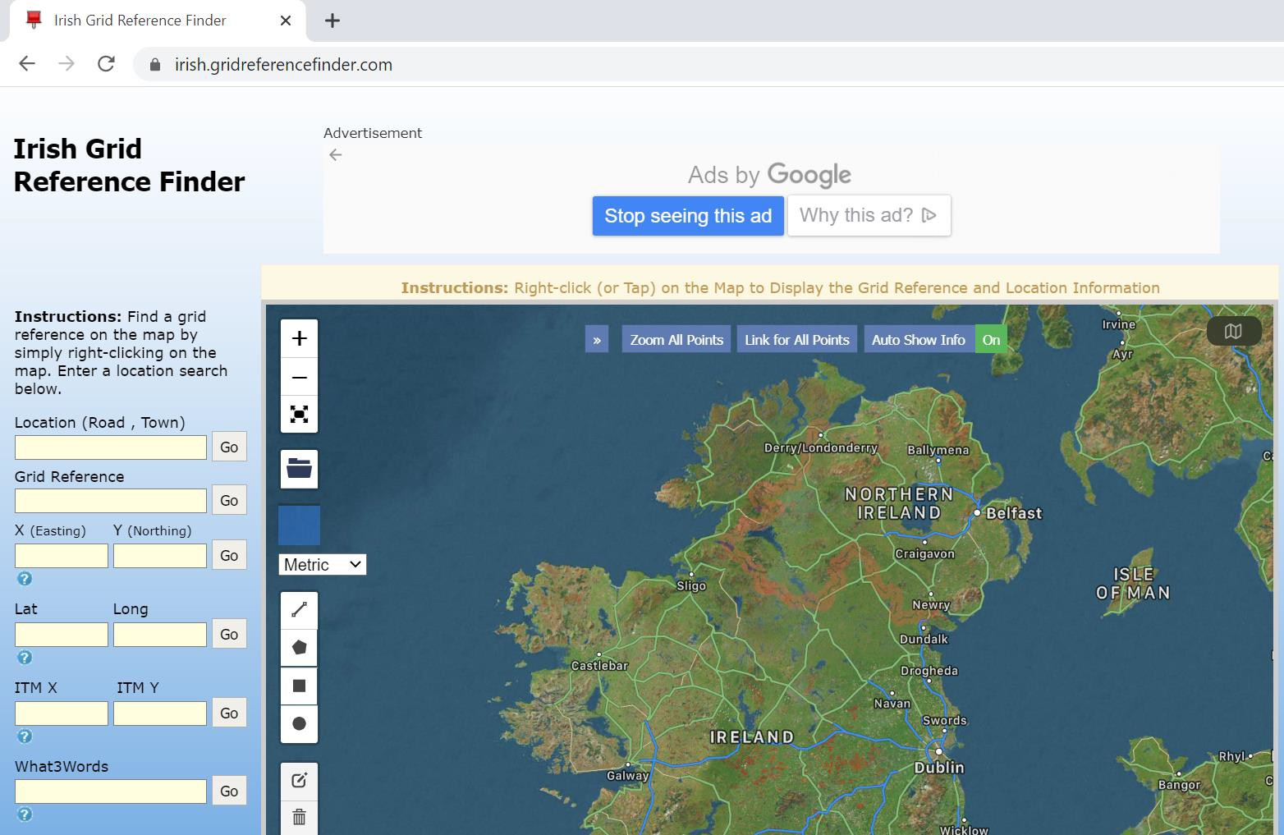
- Go to the following website: https://irish.gridreferencefinder.com/

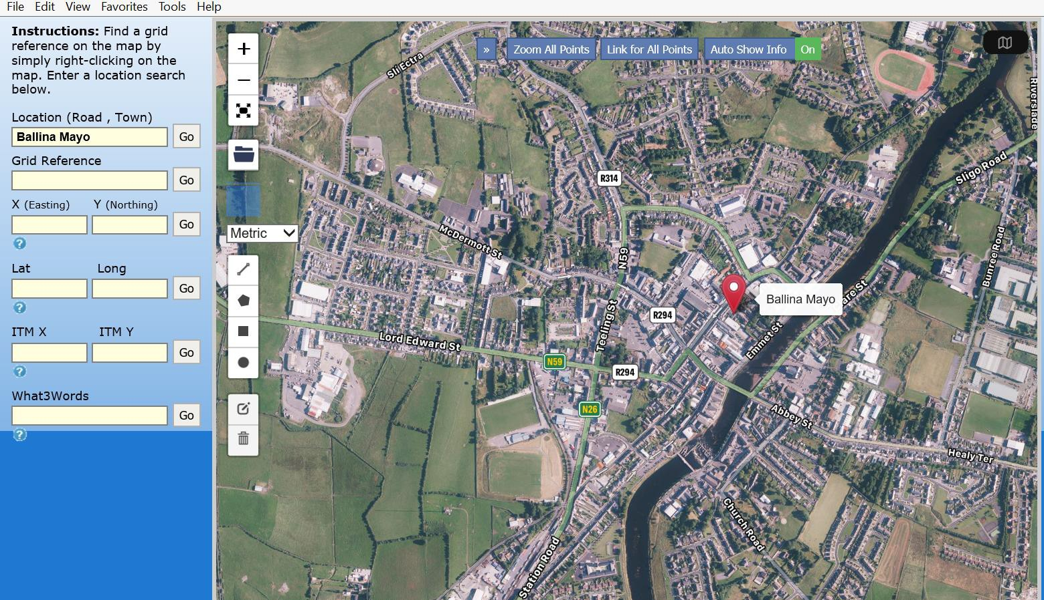

- Enter a general location into the search field where the proposed Project will be based and select GO

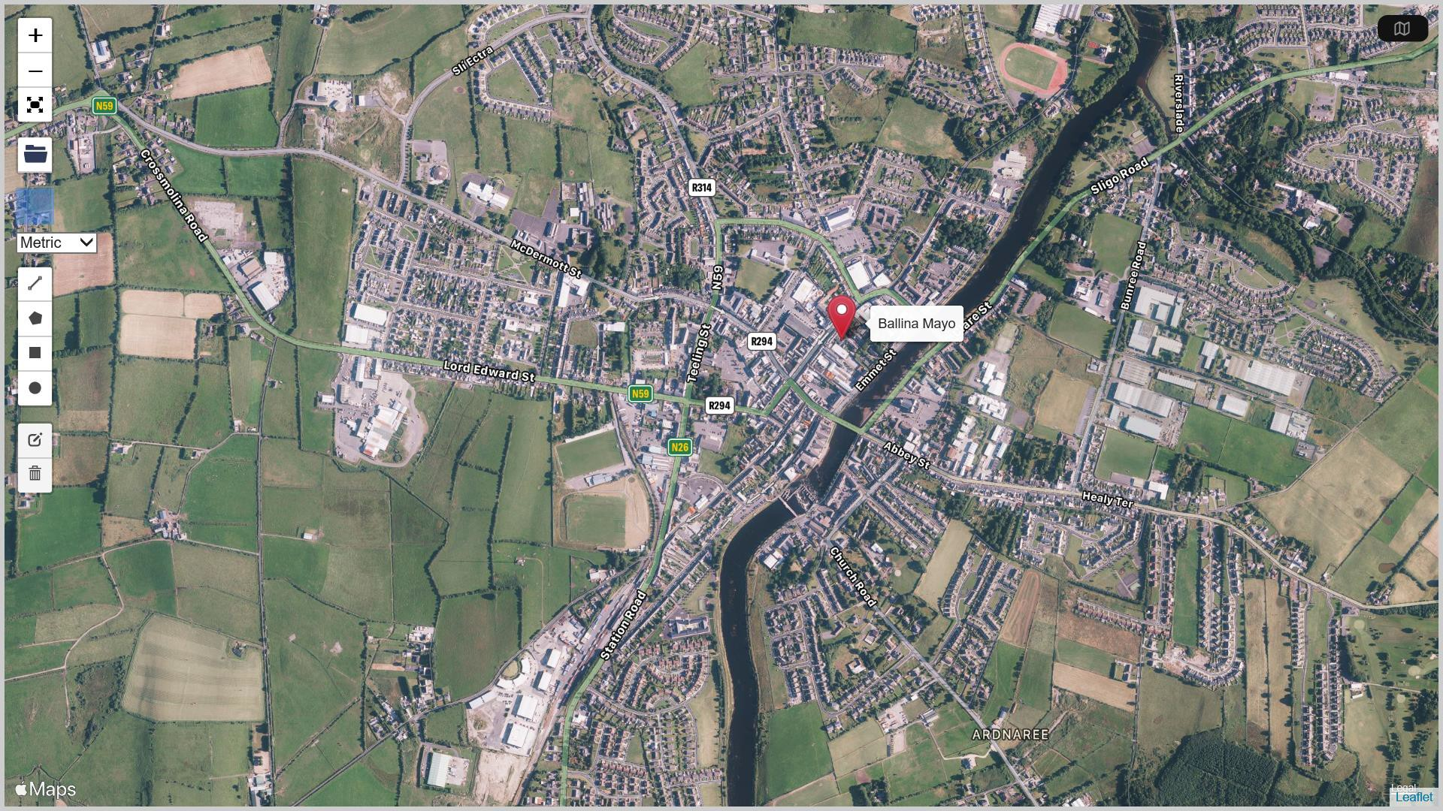

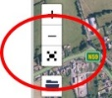
- Expand the map to full screen

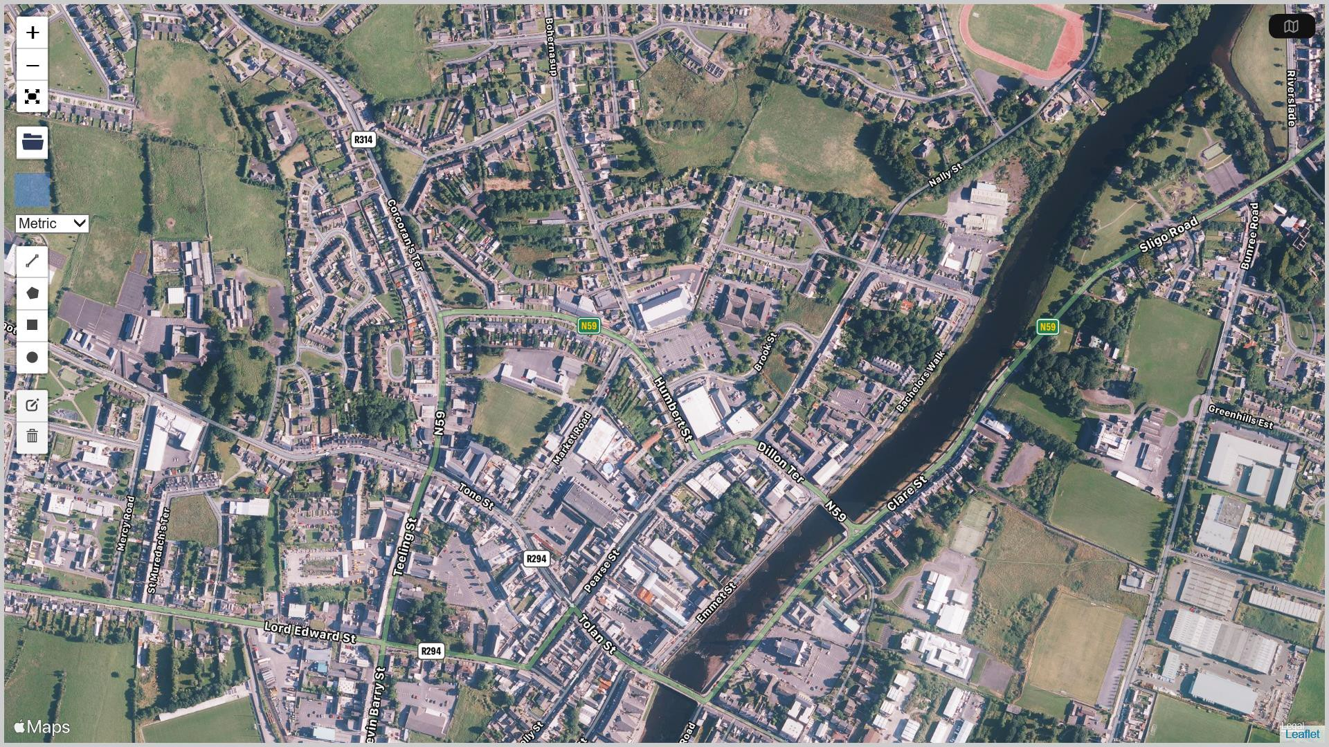

- Using your mouse and pressing on your left mouse button scroll the map to a more exact location of where the proposed project will be based.

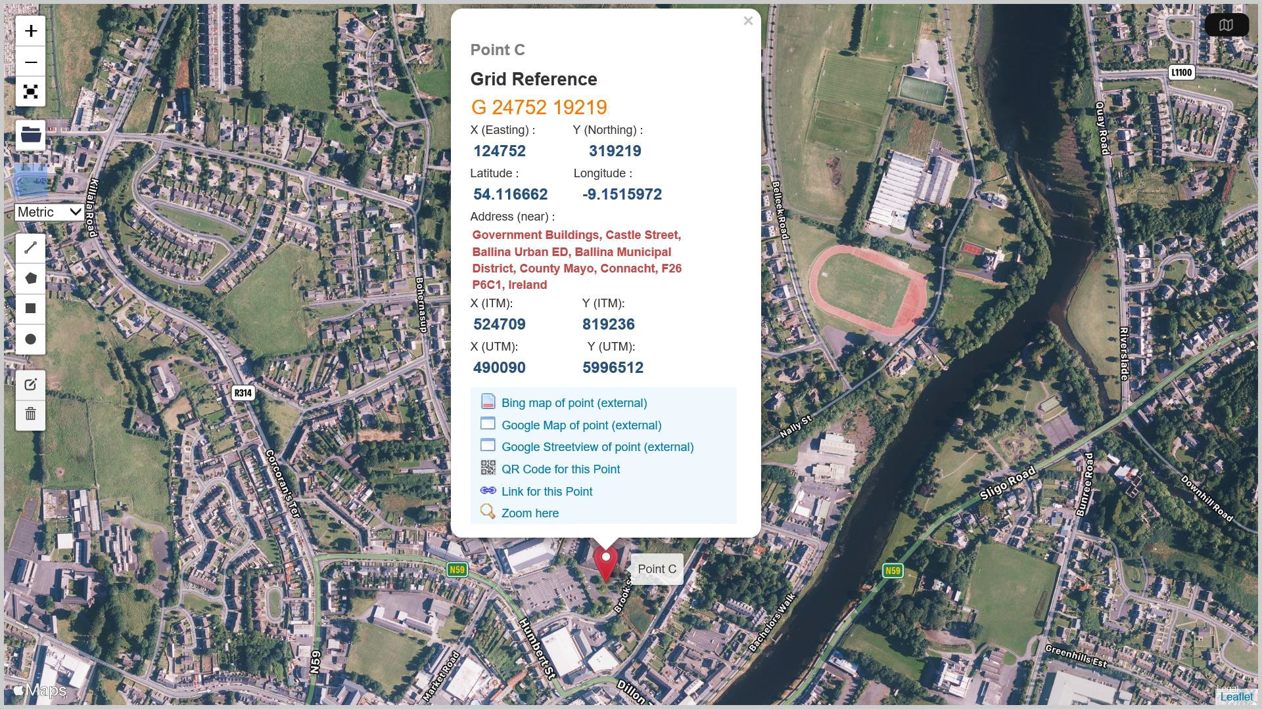
- Use the enlarge (+) or reduce (-) icons with your mouse to bring up an enlarged area/location of where proposed project will be based.
- Place your mouse pointer on the exact location and press the right button on your mouse – This will create a point with exact coordinates.
- Please note and record the X (ITM) 6 Digit coordinate and the Y(ITM) 6 Digit coordinate.

