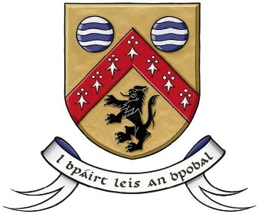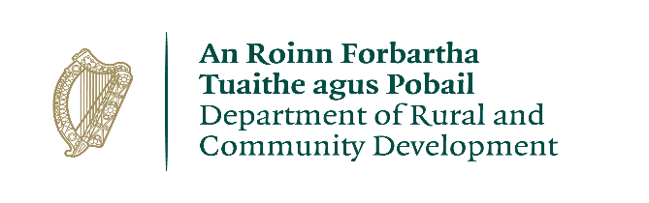
CLÁR 2021 Measure 1
Call for Expression of Interest for
School and Community Safety Measures
Closing Date: Wednesday 14th April 2021

Laois County Council is seeking expressions of interest in respect of school and community safety projects under the terms of the CLÁR Scheme recently launched by the Department of Rural and Community Development, and which the Council could consider for submission to the Department.

CLÁR (Ceantair Laga Árd-Riachtanais) is a targeted investment programme for rural areas that aims to provide funding for small infrastructural projects in areas that experience disadvantage. The aim of CLÁR is to support the sustainable development of identified CLÁR areas with the aim of attracting people to live and work there.

CLÁR 2021 will consider support for interventions that make the school/community facility environs healthier and safer for the children attending the schools, and for children and adults using the community facilities. The works can only take place to the environs of the school/community facility and not to any part of the exterior/interior of the school/community buildings.

Eligible Applicants:
Schools, Community Groups, Local Development Companies, Local Authorities.

Please refer to the 2021 Scheme Outline for more detailed information. The Scheme Outline and full details and the Expression of Interest template are available on www.laois.ie

Any application must adhere to the following requirements that:
- The project must be located in a designated CLÁR area to be able to be considered. Maps and lists of the CLÁR areas in County Laois are available on www.laois.ie

- A community recreational area must be open and available for use by the general public

How to express an interest?

Please submit your proposal by 5pm on Wednesday, 14th April 2021, either by post to: CLÁR Scheme Measure 1 2021, Sport & Leisure Section, Laois County Council, Áras an Chontae, Portlaoise Co Laois or by e-mail to: sports@laoiscoco.ie.

Your submission must be submitted using the Expression of Interest Form

All expressions of interest will be assessed by the Council and proposals can be selected for County Laois, including those put forward by the Council itself, for development into detailed applications to the Department. It is the Department who will make the final decision on selection and approval of projects to be funded.

