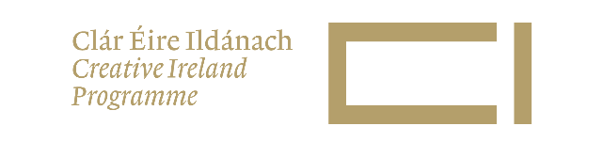
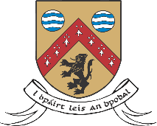

Call Out for Facilitators

Laois County Council Arts & Libraries are planning a diverse range of programming during the coming year.

We wish to invite submissions from arts and cultural facilitators and producers seeking to join a panel for programming during 2023/24.

Programming could take place during Bealtaine, Cruinniú na nÓg, Culture Night, Leaves Festival of Writing & Music or as part of other programming.

Facilitators for the panel may be chosen to deliver workshops, specialist talks, storytelling, and other tailored events to children, adults, and specialist groups. We welcome events held through Irish, English and other languages.

We are seeking facilitators in the following areas:
- STEAM activities such as Coding, Robotics, Fun Science, Virtual Reality, Electronics, and Creative Technologies.
- Literacy-focused activities including storytelling, poetry readings, drama, author talks, and creative writing. Activities aimed at specialist groups, e.g. dyslexia friendly, sensory stories etc
- Activities can also focus on Technology, development of skills in use of new technologies including: 3D Design, Audio Recording & Editing, Image Editing, Video Recording & Editing, Virtual Reality and Smartphone photography.
- Film / Visual Art / Music – performances and workshops
- Climate Change: Events raising awareness of climate change, as well as talks and workshops with an emphasis on the practical side, such as gardening and up-cycling workshops.
- Creativity: Wide range of activities that encourages and develops creativity in all ages.
- Age Friendly: Activities and events that ensure the voices of older people are represented and promote the wellbeing and quality of life of all citizens and communities.
- Youth Theatre: facilitators interested in delivering weekly workshops
- Wellbeing: Workshops and events with a focus on health and wellbeing, including but not limited to mindfulness, yoga, and play therapy.
- Live performance: music, drama, puppetry and spectacle shows for children young people and adults.

Specify which languages you can present your programme eg English, Irish, Ukrainian etc.

Where working with children, compliance is essential with appropriate legislation with regards to Health and Safety and Children First.

To be considered for the panel, please email the following to: artsoff@laoiscoco.ie
The deadline for expressions of interest is: Friday 21 April 2023

Please note:
- Successful applicants may be subject to Garda vetting.
- This is a call out for services and is based on programme requirements, budgets, your availability, and suitability.
- Facilitators will join a panel and may be offered work. Becoming a panellist does not automatically ensure that your services will be used.
- Panel membership is subject to review after a two-year period.
- The information supplied will be held for the duration of the panel and accessed only by employees of Laois Arts and Libraries.

Company / Individual name:
Contact name: | Tel no:
Address: | Email:
Website: | Social Media pages:

Please indicate which of the following areas you have experience in delivering programmes?
STEAM | Literacy | Technology | Film/Visual Art/Music | Climate Change
Creativity | Age Friendly | Wellbeing | Live performance | Youth Theatre
If Other, please specify:

Please confirm that you can provide programmes: | Please confirm maximum numbers per workshop: | Please indicate if you have a preferred age group for your workshops:
In person Yes No
Online Yes No

Please specify which languages you can present in:

Please describe the type of programme that you offer including standard duration of workshops:

Please give examples of groups that you would have worked with e.g. Pre Schools, Schools, Active Age Groups, People with additional needs, Adult learners, Community Groups etc:

Please confirm the maximum cost of workshops below
 | Total Proposed Cost (excl VAT) | Total proposed Cost incl. VAT
Rate per hour
Any Other Applicable Cost

I confirm that the above information is accurate and that the facilitators in the application:
Comply with all relevant H&S Legislation Yes No
Comply with all Public Health Guidelines in relation to COVID 19 Yes No
Comply with all Children First requirements Yes No

Signature: | Date:

