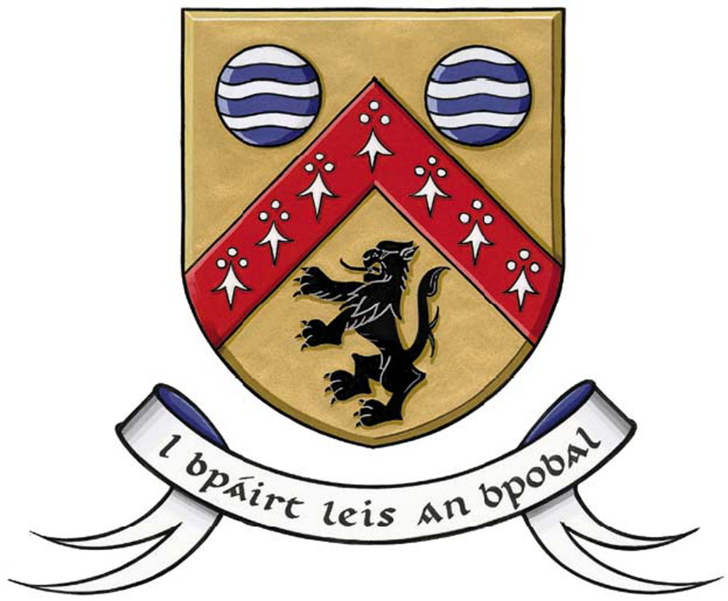
CLÁR 2020 Measure 2
Call for Expression of Interest for
Community Recreational Area projects
Closing Date: Wednesday 24th June 2020

Laois County Council is seeking expressions of interest in respect of community recreational area projects under the terms of the CLÁR Scheme recently launched by the Department of Rural and Community Development, and which the Council could consider for submission to the Department.

CLÁR (Ceantair Laga Árd-Riachtanais) is a targeted investment programme for rural areas that aims to provide funding for small infrastructural projects in areas that experience disadvantage. The aim of CLÁR is to support the sustainable development of identified CLÁR areas with the aim of attracting people to live and work there.

This Call for Expressions of Interest relates solely to Measure 2: the enhancement of existing and/or the development of new accessible Community Recreation Areas where friends and families can socialise outdoors in safe, accessible community spaces while respecting public health guidelines. This Measure will include support for items such as picnic benches/tables, outdoor covered seating or BBQ areas, public lighting, bicycle stands, bandstand/stage areas, etc. These recreational areas will be particularly important for community social interaction in the coming months, in line with the Government’s Roadmap for Reopening Society and Business.

Please refer to the 2020 Scheme Outline for more detailed information. The Scheme Outline and full details and the Expression of Interest template are available on https://laois.ie/departments/community/clar-funding-2020/

Any application must adhere to the following requirements that:
- The project must be located in a designated CLÁR area to be able to be considered. Maps and lists of the CLÁR areas in County Laois are available on
https://laois.ie/departments/community/clar-funding-2020/

- A community recreational area must be open and available for use by the general public

How to express an interest?

Please submit your proposal by 5pm on Wednesday, 24th June 2020, either by post to: CLÁR Scheme Measure 2 2020, Sport & Leisure Section, Laois County Council, Áras an Chontae, Portlaoise Co Laois or by e-mail to: sports@laoiscoco.ie.

Your submission must be submitted using the Expression of Interest Form

All expressions of interest will be assessed by the Council and proposals can be selected for County Laois, including those put forward by the Council itself, for development into detailed applications to the Department. It is the Department who will make the final decision on selection and approval of projects to be funded.

