BOOKING FORM
Looking/Seeing/Making by Bridget Flannery
Art Workshops with artist Bridget Flannery
At The Malthouse Stradbally Co Laois, R32 HP98
Tuesday 13th June to Friday 16th June
10:30am- 4:00pm (lunch 1:00-2:00pm)
NB Day One Tuesday 13th June 10:30am- Meet at the Laois Arthouse, Stradbally R32 DT28

Name ___________________________________
Contact Address __________________________________________________
Email Address ____________________________________________________
Telephone/Mobile ________________________________________________
How did you hear about the course? _________________________________

Fee €120 for the workshop, including notebook and viewfinder. Concession of €70 available for student and unemployed.
Participants provide their own art materials, and they will receive a notebook and view finder as part of the course.
Please bring lunch, drinks and snacks as required. There are no tea making facilities available. There are no parking spaces available at the Malthouse, street parking is advised.
Fees to be paid in advance with booking form – Places are limited.
Closing date for receipt of completed forms together with payment is Thursday 8th June.
Methods of Payment:
- Cheques or postal orders accepted. By Post: Please make cheques / postal orders out to: Laois County Council, include booking form with fee and can be posted to Laois Arts Office, Laois County Council, Áras an Chontae, Portlaoise, Co Laois.
- Telephone payments: By Laser or Credit Card, Contact Laois County Council Cash Office on 057 8674308 Please Quote Revenue Code AR017, Masterclasses Bridget Flannery and give your name. Cash Office Opening Hours: Monday to Friday 9.30am – 3.30pm
Please send the completed booking form to artsoff@laoiscoco.ie or The Art Office, Laois County Council, Áras an Chontae, Portlaoise, Co Laois.

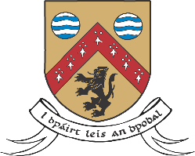
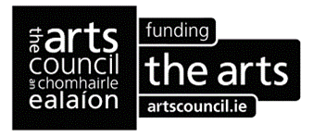
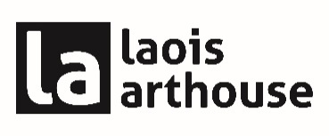
Introduction:
Laois Arthouse Stradbally annual adult summer arts programme this year features a series of workshops entitled Looking/Seeing/Making by renowned artist Bridget Flannery in the beautiful surroundings of the Malthouse, Stradbally, Co Laois, R32 HP98.
This 4-day workshop focusing on development of work through sketchbook, word gathering, collage and material gathering, composition, texture, outdoor work and colour mixing. The week concludes with an exhibition opening of Bridget Flannery’s work entitled Looking/Seeing/Making BOGLANDS and selected work by the participants at the Laois Arthouse on Friday evening, 16th June at 5pm. Family and friends are welcome. The exhibition will remain open until the end of July.
Day one Tuesday 13th June 10:30am - meet at the Laois Arthouse, Stradbally R32 DT28 for discussion, Q&A
Participants will then travel by foot or car to the Malthouse, Stradbally where the workshops will take place.

Information:
Over the four-days, Bridget will share her work methods and experience to assist and guide students. The participants gather on day one at the Laois Arthouse for induction and Q&A. This course will be taken place in a large well-ventilated studio within the beautiful private grounds of the Malthouse, Main Street, Stradbally, Co Laois. Tuition will be given both on a group and individual basis, the course is suitable for all levels.

Suggested Materials for the workshops:
Selection of preferred brushes for painting, Brushes for glue, Selection of sandpaper, Selection of papers for collage, Heavyweight paper, or card suitable for paint, Canvas x2 in preferred size (always good to have a second canvas to work on while the other is drying), Selection of paints. Rags, Water container, White glue, Shirt or apron for clothes, thin latex gloves if desired.
Paint: watercolour and acrylic. Cadmium red, cadmium yellow, cerulean blue, Alizarin crimson, azo yellow or lemon yellow, ultramarine blue, Titanium white (for mixing) and zinc white (for glazing)

Bridget Flannery:
Bridget Flannery is a visual artist living near the Laois-Carlow border in Ireland. She graduated from the Crawford College of Art and Design, Cork in 1981. Her work is mainly focused on painting and drawing. She has consistently exhibited in solo and group shows in Ireland and Europe. Her work is held in public and private collections nationally and internationally. Studio residencies include the Ballinglen Arts Foundation, Co. Mayo, Cill Rialaig Artists Retreat, Co. Kerry and The Tyrone Guthrie Centre in Co. Monaghan. She is represented by Solomon Fine Art, Dublin. She works as a Part-Time Learning Curator at VISUAL, Carlow and as a visiting tutor at Abbeyleix College of Further Education, ArtForm, Dunmore East, and numerous Plein Air painting events throughout the country.

For information on the course please contact Muireann Ní Chonaill and / or the Arts Office team at artsoff@laoiscoco.ie or phone 057 8664109

