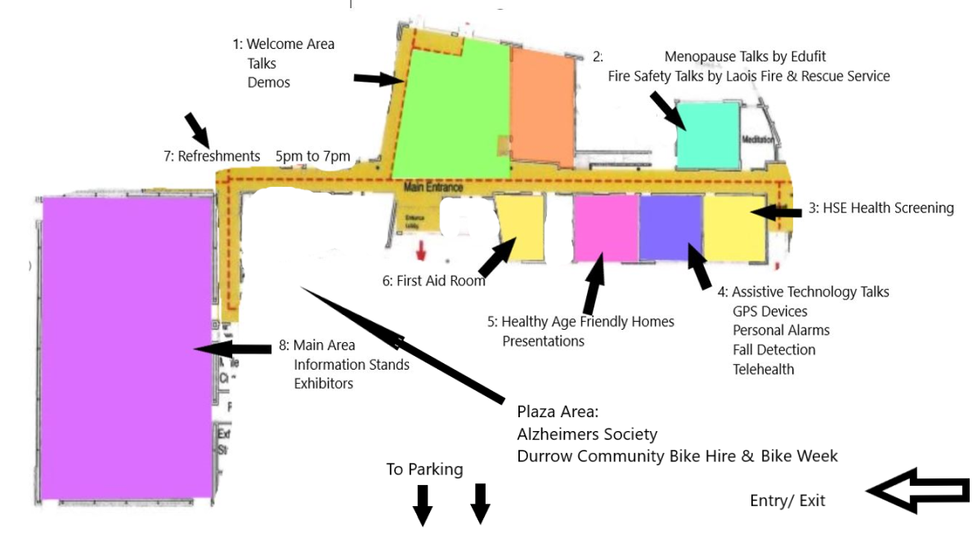
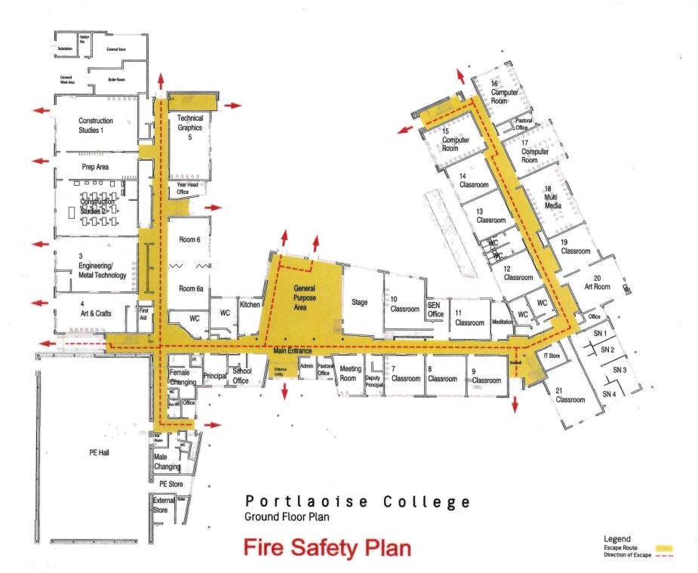
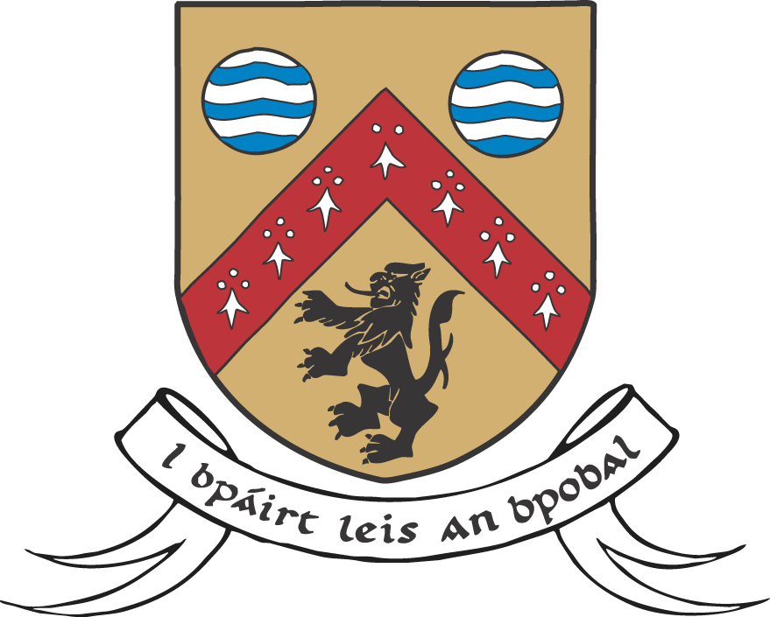
Area 1- Welcome Area
4.00pm Mallows Ukranian Choir
4.10pm Welcome & Opening - Anna Mai McHugh.
4.30pm Assistive Gadgets Made Easy by Louise Edmonds, Age Friendly Ireland.
4.50pm One Plate at a Time. Meals on Wheels – Past, Present and Future, Tracey Noone
5.05pm The Teac Tom Story with Angela Hayes, Founder of Teac Tom.
5.20pm Cooking just got Fun! with the Coalition Chefs.
6.00pm Lock it or Lose it. Crime prevention in the home, Sergeant Graham Kavanagh
6.30pm Setting Up a Women’s Shed- Carmel Cashin
6.50 pm Fun Fast and Tasty-Cooking with Janice O Brien ( LOETB)
Area 2-
5.00pm Living Well with Menopause by Edufit.
6.05pm Reducing the Risk of Fire and Carbon Monoxide in your home-Laois Fire and Rescue Service
7.00pm Living Well with Menopause by Edufit.
Area 3-
4.30pm to 7.30 Living Well Free Health Screening.
Area 4- Assistive Technology
Personal alarms, healthcare & homecare , fall detection , elder care, GPS devices, pendant alarms & telehealth.
4.40pm Task Community Care
5.00pm Isaac Care
5.20pm Tunstall Emergency Response
5.40pm Eila Connect

Area 5- Sláintecare
4.30pm Healthy Age Friendly Homes Talk
5.00pm Healthy Age Friendly Homes Talk

KEY TIMES- Area 6 - Age Friendly Healthy Homes
4.30pm & 5.00 pm Talks on the Sláintecare Healthy Age Friendly Healthy Homes rollout by Mark Harrington
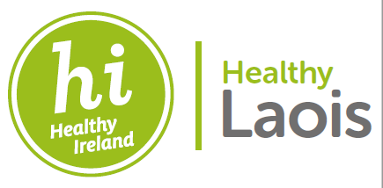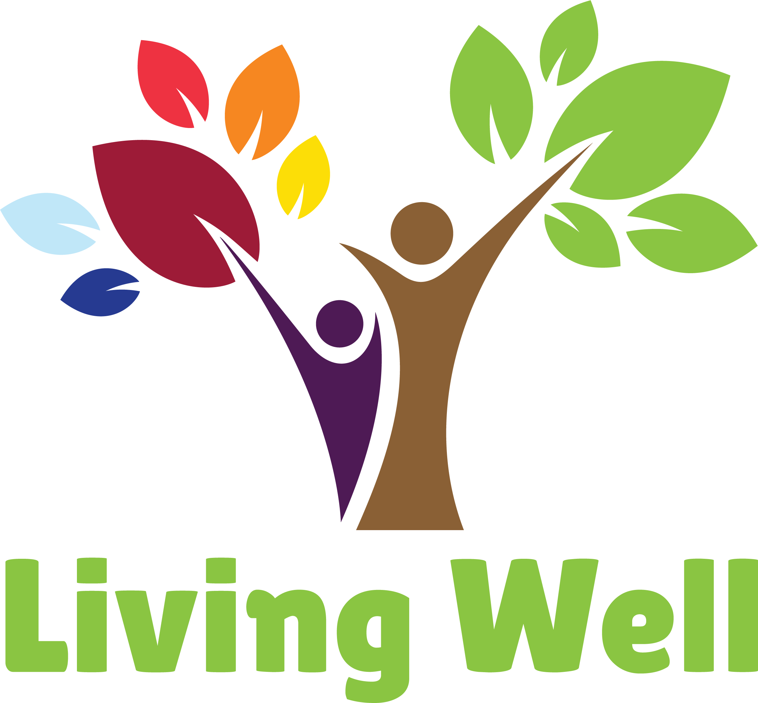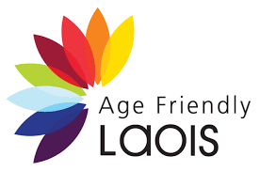

Area 6- First Aid
4.00pm-8.00pm Laois Civil Defence

Area 7- Refreshments
5.00pm-7.00pm Compliments of Age Friendly Laois and Healthy Laois

Area 8- Main Exhibition Area and Hall
4.00pm-8.00pm
Plaza-
4.00pm-8.00pm Alzheimer Society
4.00pm-8.00pm Durrow Community Bike Hire and Bike Week

Nore Vision | Healthy Age Friendly Homes | Cinema | SOSAD Laois
ALONE | Laois Libraries | Age Friendly | South Laois Beekeepers Association
An Garda Síochána | Dignity Partnership | Healthy Laois | South Leinster MABS Laois Office
Laois Volunteer Centre | Failte Isteach(Aga LP) | Irish Cancer Society | STEPP
La Leche | Laois Partnership | Laois Civil Defence | Portlaoise Tidy Towns
GAA Rounders | Laois Brazilian Support Group | Laois Domestic Abuse Service | National Meals on Wheels Network
Citizens Information | Laois African Support Group | Clonad GAA | Tunstall Emergency
Isaac Care | Laois Bridge Clubs( 4 tables squared) | Alzheimer Society Laois | Uccello Designs
Marie Keating Foundation | Laois Chamber Alliance | Durrow Community Bike Hire & Bike Week | Portlaoise Family Resource Centre
Fire & Rescue Service | Laois Federation ICA | Portlaoise Panthers | NCBI Working for People with Sight Loss
Eila Connect | Laois Leisure | Midlands LGBT+ | Home Instead
Jigsaw Laois/Offaly | Irish Wheelchair Association | Youth Work Ireland Laois
AIB | Arthritis Ireland- Laois | PPN Laois
Water Safety Ireland | Laois Sports Partnership | Local Link
Senior Line | Edufit | Laois Community & Vol Awards
HSE- Social Work in Primary Care | Dunamaise Arts Centre | Laois County Council Community & Climate Action
HSE ICPOP | TASK Community Care | Laois County Council Housing & Planning
HSE Health Promotion and Improvement | Laois Traveller Action Group, | Laois County Council Environment & Broadband
Mental Health Ireland | Chime | Music Generation Laois
HSE Resource Office for Suicide Prevention | Teac Tom | Park Run Vicarstown
Breast Cancer Ireland | LOETB Community Education | SVT
HSE START | People's First Credit Union | Mountrath Youth Theatre

