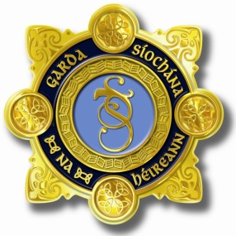
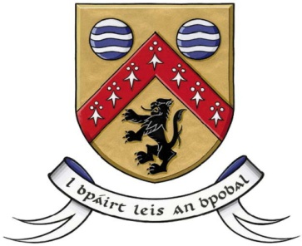

Laois County Joint Policing Committee Meeting
Annual Public Meeting
Áras an Chontae, Portlaoise
4th March 2019 at 11.30 am

AGENDA

- Confirmation of Minutes of Joint Policing Committee Meeting held on 19th November, 2018 (copy attached)
- Matters Arising
- Report from An Garda Síochána
- Laois County Council Report
- Approval of Community CCTV Schemes
- JPC Strategy (a) Annual Report 2018
(b) Draft Implementation Plan 2019 (Documentation to follow)
- Any Other Business

