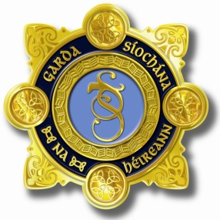
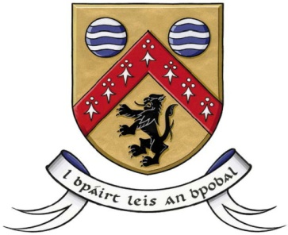

Laois County Joint Policing Committee Meeting
Annual Public Meeting
Áras an Chontae, Portlaoise
19th November 2018, at 3.30pm

AGENDA

- Confirmation of Minutes of Joint Policing Committee Meeting held on 10th September, 2018 (copy attached)
- Matters Arising
- Report from An Garda Síochána
- Laois County Council Report
- Questions submitted by members of the public
- Any Other Business

