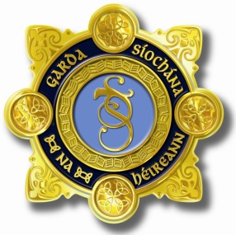
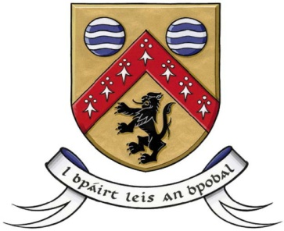

County Laois Joint Policing Committee Meeting
10th September 2018 at 2.30 pm
at Áras an Chontae, Portlaoise

AGENDA

- Confirmation of Minutes of JPC Meeting held on 16th July,2018
- Matters Arising
- Report from An Garda Síochána
- Laois County Council Report
- Any Other Business

