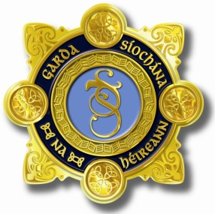
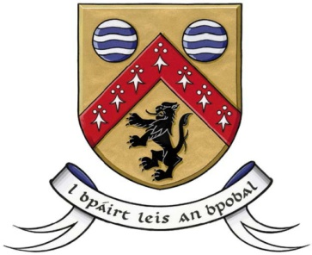

Laois County Joint Policing Committee Meeting
Annual Public Meeting
Áras an Chontae, Portlaoise
14th October 2019 at 10.00 am

AGENDA

- Confirmation of Minutes of Joint Policing Committee Meeting held on 4th March, 2019 (copy attached)
- Confirmation of Minutes of Joint Policing Committee Election of Chairperson meeting held on 25th September, 2019 (copy attached)
- Matters Arising
- Report from An Garda Síochána
- Laois County Council Report
- Approval of Community CCTV Schemes
- JPC Strategy Implementation Plan 2019 – Update on actions
- Proposed meeting dates for 2020
- 16th March 2020 at 10.00 am
- 15th June 2020 at 10.00 am
- 21st September 2020 at 10.00 am
- 16th November 2020 (Public Meeting) at 3.30 pm

- Any Other Business

