HOW TO REGISTER FOR MYCOCO PAYMENTS

- Go to www.mycoco.ie
- Scroll to bottom of page & under Payments, click on Register Account
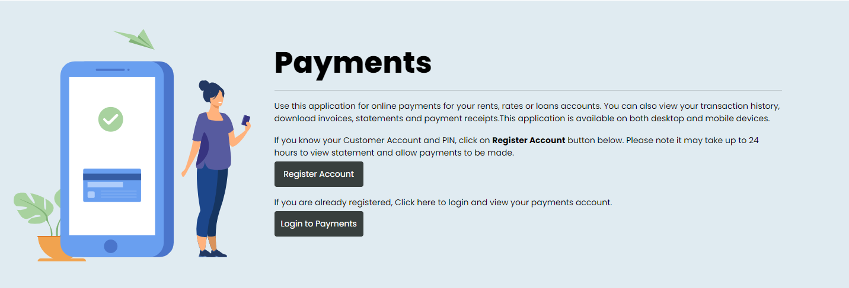

- Select Laois County Council as the Local Authority
Enter your Customer Number. This is the same number you use to make payments. It is also available on your statement. For queries regarding your Customer Number, please contact Niamh Bright on 057 8689320.
- Enter your PIN included in the attached letter. Click Next.

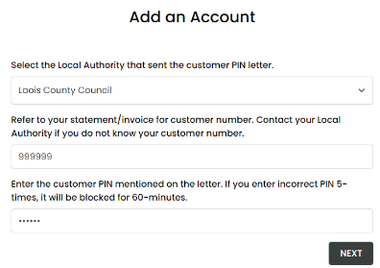

- Register email address for MyCoCo account
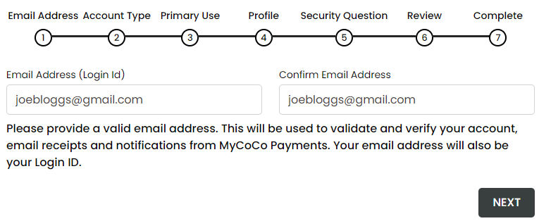

Please ensure you use a valid email address as a temporary password will be sent to this address to complete the registration process. Your email address will also be your Login ID used to login to MyCoCo. Notifications, receipts, and other emails such as password changes will also be sent to this address. Click Next.

- Select Account Type
A Fire Charges customer should select Individual in the screen below as usage will be mainly for payments and non-business use. Click Next.
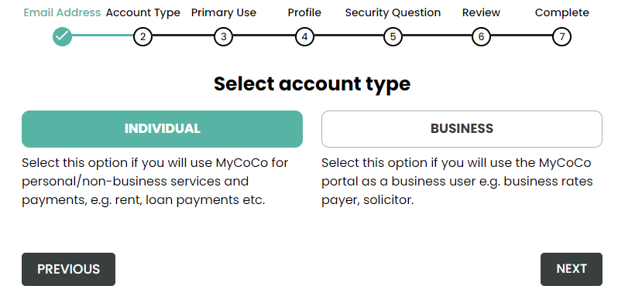

- Primary Use
A Fire Charges customer should select Payment Account. Click Next.
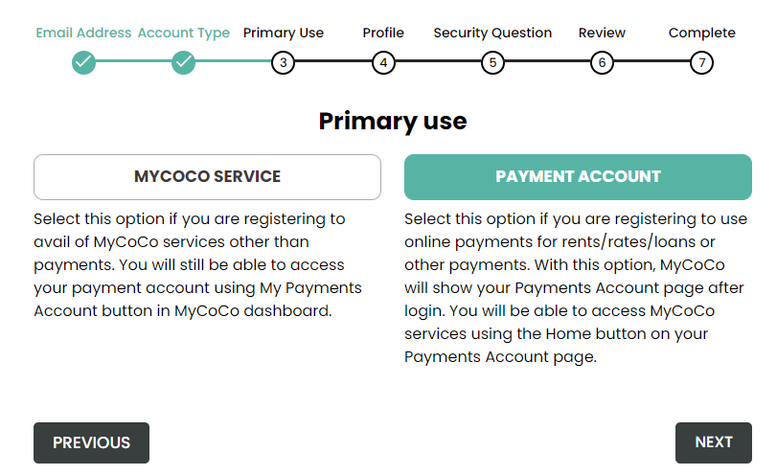

- Complete your profile
Please enter your name, address and phone details. This information may be used by Laois County Council staff to confirm your identity when you contact us in relation to your account.
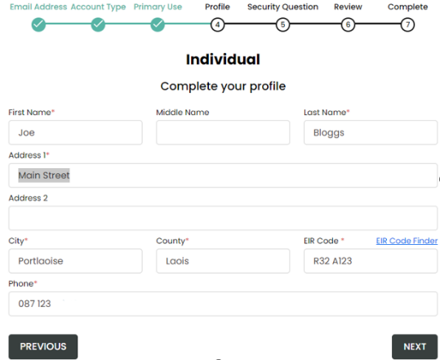

- Security Question
This is an optional step. Nonetheless, we advise that you create a security question because Laois County Council may ask you for it to confirm your identity when your query your MyCoCo account
.
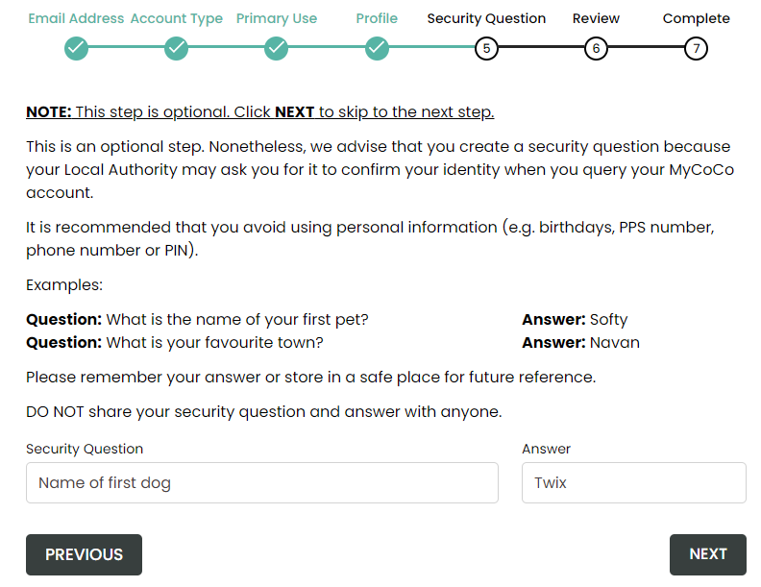

- Summary Profile Information
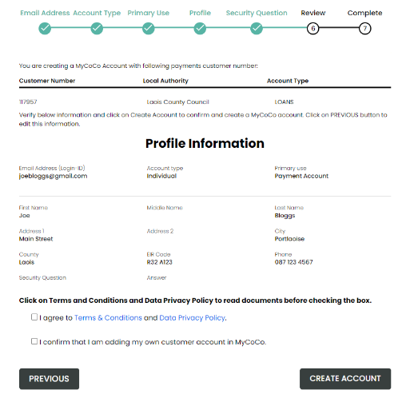
If the Customer Account number and Profile Information is incorrect, click Previous to return to Profile screen to make amendments. If correct, you must agree to the Terms & Conditions, Data Privacy Policy and confirm you are adding your own customer account to MyCoCo. Click Create Account to continue registration.

- Registration Nearly Complete
A temporary password will now be sent to the email address used to register. (Please check your Spam/Junk Folder as email may appear here)
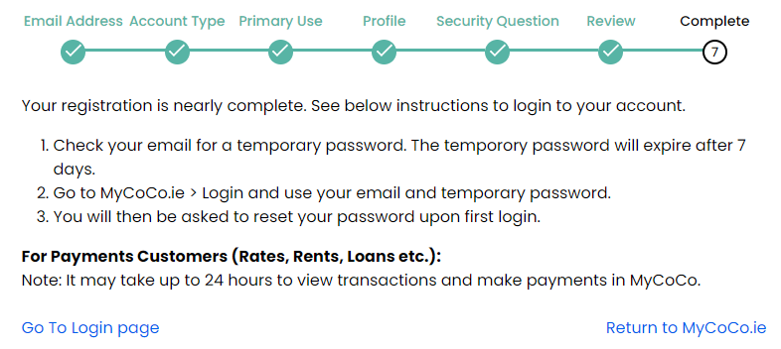

- Login to MyCoCo
Go to your email and copy your temporary password into the link provided to login.
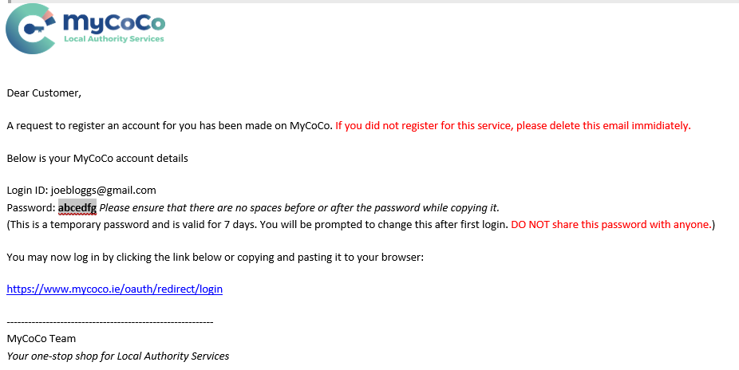

Login with your email address and temporary password. (image 1). You will then be prompted to set a permanent password (image 2)
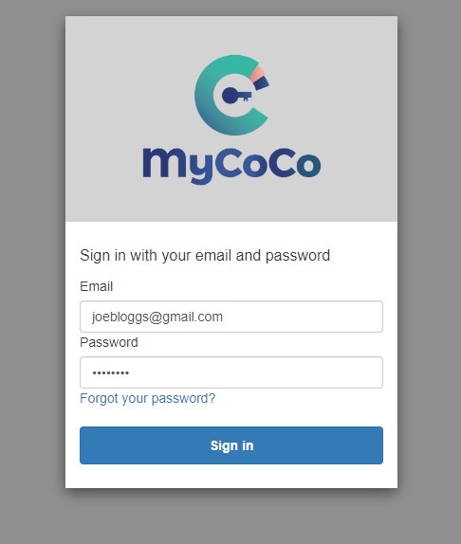
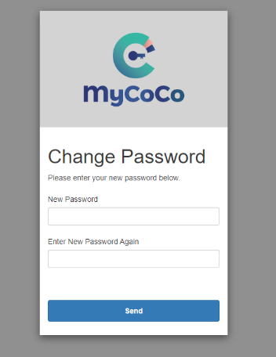
IMAGE 1 IMAGE 2

ONCE REGISTERED, IT MAY TAKE UP TO 24 HOURS TO ENSURE YOU CAN MAKE PAYMENTS AND VIEW TRANSACTIONS.

HOW TO MAKE PAYMENTS ON MYCOCO
After 24 hours, you will be able to make payments on your account. To make a payment;
- Go to www.mycoco.ie
- Click Login in top right of the window
- Login using your email address and your password.
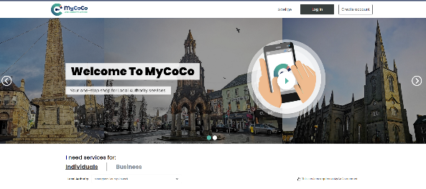

- Go to Departments > Fire and Select Pay Now
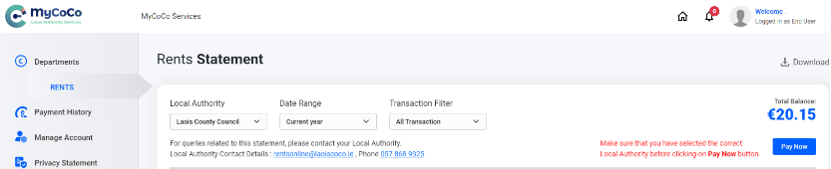

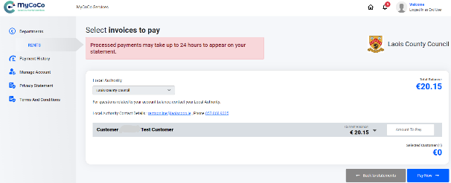
- Enter the Amount to Pay and Select Pay Now

- To edit the amount, Select Edit, otherwise select Pay Now.
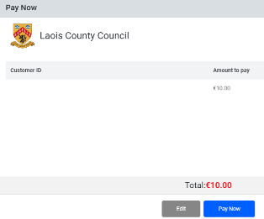

- In the Additional Information screen, confirm the details match the cardholder being used & select Pay Now.
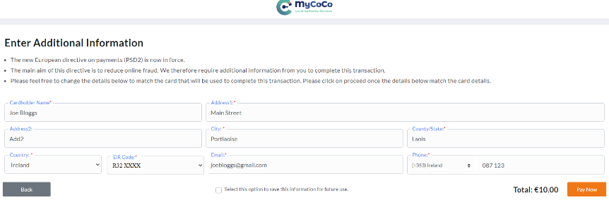

- Enter Card details and click Confirm Payment.
- On successful payment a receipt will be issued to your email.
If you require assistance, please contact 057 8689320

