 Clean Up Laois Week 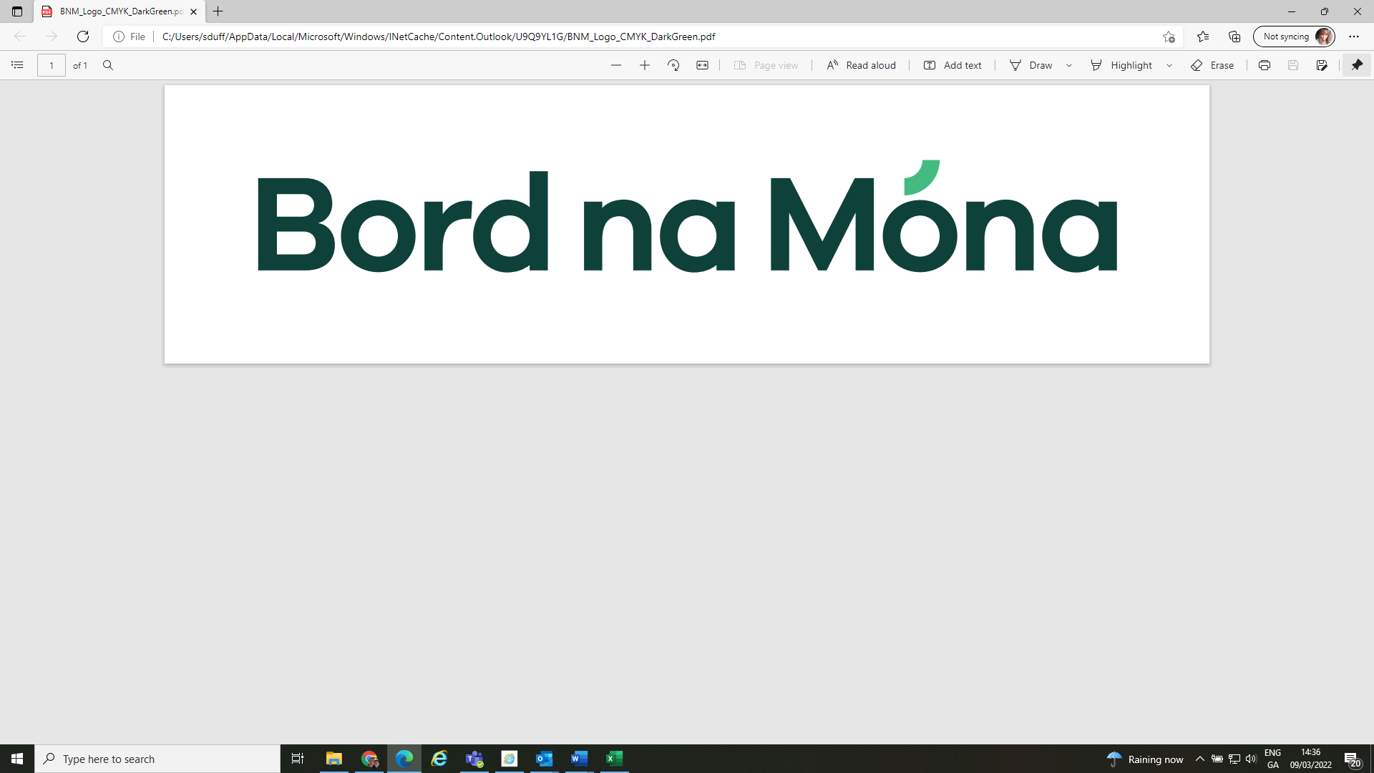

31st March to 4th April 2025

## Registration Form

# Name of Group/Assoc ____________________________ No. Involved ___________

# Address ______________________________________________________________

# Contact Person ______________________________________________________________

# Tel Number(s) _________________ E-mail address __________________________

**Area to be cleaned (provide details) __________________________________________________________________________________**

**__________________________________________________________________________________**

**Collection pick up point – full address and Eircode**

**__________________________________________________________________________________**

Forms to be returned by Friday 14th March 2025. Packs will be available for collection from County Hall, Portlaoise.

This list is not an extensive list of all the areas covered but should give a general idea of when bags in your area will be collected. If you are unsure of your collection date, please contact the Environment Section on 057 86 89315 or email us at [cleanupweek@laoiscoco.ie](mailto:cleanupweek@laoiscoco.ie)

|  |  |  |  |  |
| --- | --- | --- | --- | --- |
| Mon 7th April | Tue 8th April | Wed 9th April | Thur 10th April | Fri 11th April |
| * Portarlington * Ballybrittas * Killenard * Mountmellick * The Heath | * Emo * Vicarstown * Rosenallis * Clonaslee * Ballyfin | * Clough * Ballacolla * Errill * Rathdowney * Pike of Rushall * Durrow * Cullohill * Donaghmore * Rathmakelly * Coolkerry * Castletown * Camross * Coolrain * Borris in Ossory | * Mountrath * Portlaoise * Clonad * Killasmeestia | * Abbeyleix * Stradbally * Timahoe * Ballylinan * Arles * Barrowhouse * Killeshin * Ballickmoyler * Graigeucullen * Shanahoe * Ballinakill * The Swan * Spink |

*Continued overleaf: -*

* **Collection of rubbish by Bord na Mona will ONLY OCCUR THE WEEK AFTER CLEAN UP from 7th to 11th April 2025 in bags provided to you by Laois County Council.**
* **Please review the collection schedule overleaf as this may influence when you undertake your clean up.**
* **Clean Up Laois branded sacks and An Taisce sacks will be distributed to all registered groups and will be the only ones collected by our campaign sponsors**

**Bord na Mona.**

* **Please note that participants are responsible for their own health and safety, and we recommend that all groups register with An Taisce to ensure they will be covered by their Public Liability Insurance for National Spring Clean activities.**
* **Please visit** [Clean-up-Laois-week-booklet.pdf](https://laois.ie/wp-content/uploads/Clean-up-Laois-week-booklet.pdf) **for tips on how to organise your clean up, stay safe and help promote your event.**
* **Please segregate clean and dry** recyclable **goods at source for separate recycling (this may not be necessary as items that are collected are probably neither clean nor dry)!!**
* **Return the completed form to** [**cleanupweek@laoiscoco.ie**](mailto:cleanupweek@laoiscoco.ie) **or to Environment Section, Laois County Council, JFL Avenue, Portlaoise, Co Laois.**
* **I/we understand that only litter and litter related items will be collected during our Clean Up i.e., no bulky waste, domestic waste or green waste e.g., grass or hedge cuttings will be accepted.**

**PLEASE SIGN BELOW TO INDICATE YOU HAVE NOTED THE IMPORTANT INFORMATION ABOVE:**

**Signed: _____________________________ On behalf of: __________________________________**

Collections by Bord na Mona will occur between 7am and 6pm during the week so please ensure clear access to where you leave out your collected materials.

|  |  |  |  |
| --- | --- | --- | --- |
| L | No. | C | PUN |

*Office use only:*