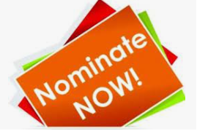

**Laois Community & Voluntary Awards 2024**

🌟 **Call for Nominations!** 🌟

We're excited to announce that Laois County Council is now accepting nominations for our upcoming Community & Voluntary Awards. Do you know someone who deserves recognition for their outstanding contributions? This is your chance to shine a spotlight on them!

Never has Community spirit and voluntary effort been so important and valuable, in sustaining all of our communities. Laois County Council in conjunction with Laois PPN and our long-standing sponsor People First Credit Union, wishes to recognise community organisations and individuals who work tirelessly in their community in the 2024 Community & Voluntary Awards.

The purpose of the awards is to acknowledge groups and individuals who, through their commitment to voluntary and community activities, have played a significant role, in enhancing the quality of life in their communities.

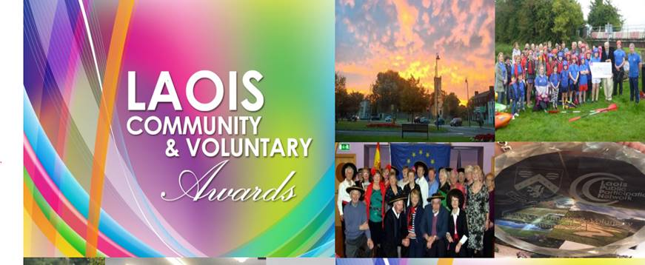

Launching the awards in the idyllic surroundings of Emo Court, the Cathaoirleach of Laois County Council, Cllr. Paschal McEvoy noted ‘’There are so many selfless individuals throughout the county, who freely give up their time, to help those within their community. These awards are a brilliant way to recognise the tireless work they do.’’

Donal Brennan, Director of Services, Laois County Council invited people to enter this year’s awards citing.

‘’Each year the Community & Voluntary Awards rightly celebrates and acknowledges the significant and highly valued role that volunteers play in our communities; Laois County Council is delighted to host the event in association with our partners Laois PPN and People First Credit Union.’’ he said.

‘’The Irish proverb “ar scáth a chéile a mhaireann na daoine” recognises that that we all rely on others in our community in order to thrive.  Volunteers are the backbone of community organisations across the County. The efforts of volunteers make our society a better place to live for all. The Community & Voluntary Awards each year recognises that contribution of volunteers across the county.’’ He concluded.

Speaking on behalf of People First Credit Union, Carol Murphy, Marketing Manager said; “People First Credit Union is proud to return once again as the main sponsor of the Laois Community and Voluntary Awards. These awards celebrate the invaluable contributions of local volunteers who tirelessly work to enhance the quality of life in our communities. We are honored to partner with Laois County Council and Laois Public Participation Network in recognizing the extraordinary dedication and impact of volunteer groups across the county.

Mr. John Oxley, Chairperson of Laois PPN: “The spirit of community and volunteering is incredibly strong in Laois. The Community and Voluntary Awards are an opportunity to celebrate the individuals and groups who enrich all our lives with their selfless work and to highlight the tremendous Community work happening in Laois day in and day out. The Community and Voluntary Awards have given well-deserved recognition to many fantastic groups and unsung heroes over the years, and we look forward to shining a spotlight on more of their great work this year.A special thanks to our main sponsor of the Awards, People First Credit Union for their continued support. We wish all the groups who enter this year the very best of luck."

Managing editor of the Leinster Express, Laura McLoughlin was delighted to attend the launch of this year's awards.

"Community spirit is truly alive and well in Laois. Right across the county volunteers and community groups are going that extra mile to support their towns and villages through fundraising, helping to keep their areas litter-free or organising events that bring people together," said Laura.

"Incredible work is being done and these awards are a fantastic way to recognise and celebrate those volunteers”

So, go ahead and get nominating your local community and voluntary groups and individuals.

**Categories for 2024 are:**

**Arts, Culture & Heritage Award** – This award recognises Groups/Organisations who enhance their local areas, by conserving, protecting and promoting the Arts, Culture and Heritage of their local community through collective creative activities. Examples include - Drama, Music, Literature, Arts, Festivals, Conservation, and Heritage. – **Sponsored by LCC Arts & Heritage Sections**

**Social Inclusion Award** – This award recognises Groups/Organisations that actively work in a supportive role in their communities and whose aim is to minimise social exclusion and/or help to improve the quality of life for socially excluded groups. Examples include working with the elderly, People with Disabilities, Ethnic Minority, Travelling Community, Young people in transition, LGBTI+ and the Homeless. – **Sponsored by Laois Partnership Company**

**Sports Award** - This award is to recognise and celebrate group in our local communities from clubs, and community organisations that go above and beyond in their efforts to promote community sport and physical activity opportunities.  This award aims to acknowledge groups or organisations that provide a leading role in their communities to help to improve the quality of life and reduce barriers to participation through physical activity or sports. – **Sponsored by Laois Sports Partnership**

**Climate Action Award -** This award recognises communities carrying out awareness initiatives and/or actions that make a positive contribution against climate change. Climate actions can encourage your community to improve the impact of their everyday choices, support local communities and foster a sustainable approach to protecting the environment. – **Sponsored by LCC Climate Action Section**

**Best Kept Residential ESTATE Award** - This award recognises the hard work and dedication shown in residential areas throughout Laois, recognises the great pride people have in their own communities, recognise the value of our biodiversity, and continue to put in a huge effort, on behalf of the places where they live. – **Sponsored by LCC Environment Section**

**Health and Well Being Award** - This award recognises community health and wellbeing initiatives i.e. mental health, sexual health, awareness raising & promotion around medical conditions, disorders, and disabilities, including opportunities for social connections, increased meaningful daily activities, developing confidence and providing a sense of purpose & positive self-worth for citizens in the community. – **Sponsored by Laois Local Community & Development Committee (LCDC)**

**Junior Volunteer of the Year Award**. This award recognises the outstanding contribution young people throughout the county, have made to their local Community. Every community has individuals who are boundless in their energy and determination to get things done. – **Sponsored by Laois Volunteer Centre**

Each group and individual nominated will be presented with a Certificate acknowledging their contribution to the community and voluntary effort in Laois. There will also be award winners and runners up across a range of categories. One of the most anticipated awards each year, goes to an individual, who the judges believe puts in such effort that they can be regarded as somewhat of an **Unsung Hero**, for the work they do.

**How do I nominate**?

To submit a nomination, simply click on the link below

1. complete the online forms that are available to you on <https://laois.ie/departments/community/community-voluntary-awards-2023/>
2. Log onto the Submit <https://laoiscoco.submit.com> which will be Live for Nominations **from Tuesday, 28th May, 2024**.
3. Download Nomination form from <https://laois.ie/departments/community/community-voluntary-awards-2023/> and email completed form to : [awards@laoiscoco.ie](mailto:awards@laoiscoco.ie) or post hardcopy to **Community Section, Laois County Council, Áras an Chontae, Portlaoise**
4. Hardcopy Nomination forms (only if required) are also available by contacting Community Section, Laois County Council, Áras an Chontae, Portlaoise- Tel no. 057-8664236.

For further information on the Terms & Conditions, please call 057-8664236 or email [awards@laoiscoco.ie](mailto:awards@laoiscoco.ie)

Closing Date for receipt of Nominations is **Friday, 26th July, 2024 at 4.00pm**

Help us celebrate the remarkable individuals in our community! Nominate someone today and let their extraordinary stories inspire others.

**#NominationsOpen #RecognisingExcellence #CommunityHeroes #Inspiration**