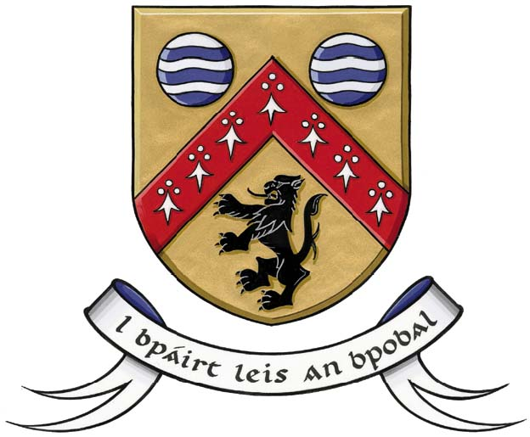
LAOIS COUNTY COUNCIL
COMHAIRE CHONTAE LAOISE
ROADS AND TRANSPORTATION

Parking Fine Appeals Form - Fixed Charge Penalty Notice

Appeals will not be accepted for any of the following offences:-

- Parking on Double Yellow Lines
- Parking a vehicle in an illegal manner e.g. parking outside a marked bay in a public car park, in a hatched area, on a footpath in a public car park.
- Parking in a manner likely to cause an obstruction e.g. parking on a corner or footpath
- Parking in a disabled Bay without displaying a valid Disability Permit
- Parking in an illegal place, e.g. Bus Bay, Taxi Rank, or in a pedestrianised area
- Parking in a Loading Bay without displaying a commercial tax disc, commercial parking for longer than the time allowed or without load or unloading being observed
- Parking on a Single Yellow Line at a time forbidden.
- Any other form of illegal parking.
Only an appeal received by Laois County Council within 14 days of the issue date of the Fixed Charge Penalty Notice will be accepted.
If, as the registered owner of the vehicle, you were not driving the vehicle at the time of the alleged offence, you must notify Laois County Council of the name and address of the person driving the vehicle within 28 days of the date the ticket was issued (Under S. 3 (3) of the Local Authorities (Traffic Wardens) Act 1975 – 4(1).
Please note that if your appeal is unsuccessful, you will be liable for any increase in the penalty, irrespective of any delay occurring during the processing of this appeal and you will be open to prosecution.

Please ensure all relevant documentation is attached (including ticket number)

Fixed Charge Notice No:

Registration No:

Date Issued:

Location Ticket Issued:

Reason for Appeal:

Name (BLOCK CAPITALS) :________________________________________

Address (BLOCK CAPITALS): ______________________________________

Date: ______________________ Tel No: _______________________________

COMPLETED FORM TO BE RETURNED TO PARKING FINE APPEALS, ROADS DEPARTMENT, COUNTY HALL, PORTLAOISE, CO. LAOIS or email parking@laoiscoco.ie
Phone 057 – 8689350 with any queries.

Upon receipt of your appeal:

- We shall process the appeal in accordance with the appeal procedure
- The appeal will be considered in conjunction with the evidence supplied by the Traffic Warden in relation to the issue of the ticket.
- We shall notify you in writing of the decision
- We shall record details of your appeal for control and audit purposes.

For Office Use Only:-

Received On:
Decision:

