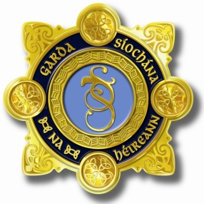
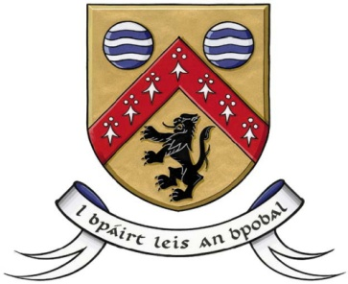

County Laois Joint Policing Committee Meeting
16th July 2018 at 11.30 am
at Áras an Chontae, Portlaoise

AGENDA

- Confirmation of Minutes of JPC Meeting held on 9th April,2018
- Matters Arising
- Report from An Garda Síochána
- Laois County Council Report
- Presentation by Patrick Clavin, Detective Chief Superintendent, Criminal Assets Bureau.
- Any Other Business

