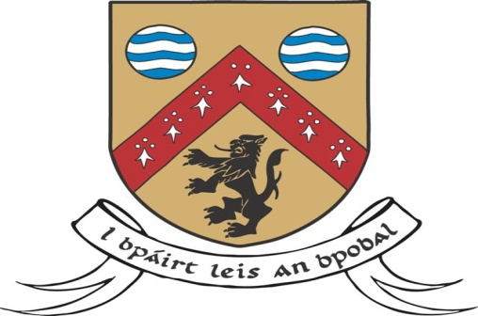

LAOIS COUNTY COUNCIL
INVITATION TO TENDER TO FACILITATE LAOIS COMHAIRLE NA nÓG

Laois County Council is inviting tenders from suitably qualified locally based individuals/organisations to tender to facilitate and support the development of Laois Comhairle na nÓg as a strong inclusive structure for the participation of young people in local decision making and informing policy, for two years, 2019 and 2020, subject to funding.

Laois Comhairle na nÓg is a local ‘Youth Council’ of young people, aged between 12 and 18 years, elected from the three Municipal District areas in Laois. The purpose of Comhairle is to give young people the opportunity to have a voice and to be involved in the development of local services and policies.

Comhairle na nÓg is led at national level by the Department of Children and Youth Affairs under the National Policy Framework for Children and Young People, with the funding being administered through POBAL. At local level, responsibility rests with each Local Authority.

The primary aim is to continue to develop Laois Comhairle na nÓg into a strong inclusive, collective voice for young people across Laois by:
  - Supporting the implementation of the Laois Comhairle na nÓg Annual Work Plan, which is a plan developed from issues and topics as identified by the young people themselves.
  - Continuing to build on Laois Comhairle na nÓg as a consultative forum and facilitating the interaction of Comhairle na nÓg with policy makers and service developers locally and nationally to ensure that the views of young people are included in shaping policies and services.

Closing date for receipt of proposals is 4.00pm on Tuesday 30th October, 2018. Tenders received after this time will not be accepted.

Tender document available by email: dce@laoiscoco.ie, or download from www.laois.ie. Laois County Council will acknowledge receipt of all applications and inform applicants of the decision in relation to the appointments made.

All of the necessary documents required for the complete tender must be returned, in duplicate and hard copy, in a sealed envelope marked “Tender to facilitate and support the development of Laois Comhairle na nOg”

Proposals should be submitted to:
Pamela Tynan,
Community Development Section,
Laois County Cuncil,
Aras an Chontae,
Portlaoise,
Co. Laois.
Phone (057)8664060 email: dce@laoiscoco.ie

‘In Partnership with the Community’

